Jiangsu Zhenhua Xinyun Electronics Co., Ltd.

Capacitor Series Description

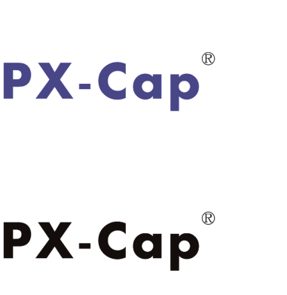

* Cathodes for capacitors are organic polymers，ESR（Equivalent series resistance） low to 9mΩ.
* Operating temperature range of -55℃ to 125℃ for 2000H*1.
* Optional gold-plated terminations, better preservation and solderability.
* Nonflammable, more safety.

**PXT、PXH**

**P．1 – 11**

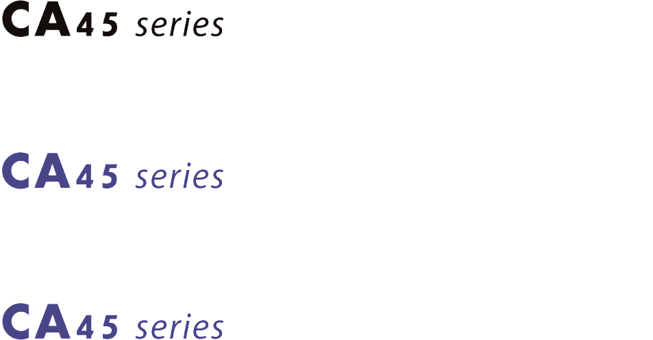

* Excellent electrical performance, high capacitance with small volume.
* High reliability and long operating life (125℃ 2000H).
* Good frequency characteristics.
* Wide range of operating temperature (-55℃ ~125℃).

**CA45、CA45A、CA45B**

**P．12 – 30**



* Conductive polymer electrolyte, low ESR (Equivalent Series Resistance), good ability of capacitance impedance frequency and to resist ripple current, stable temperature performance.
* Within the rated voltage range, no need to derate voltage；Not easy to burn or explode.
* Good electrical performance and storage stability and long operating life（105℃ 2000H）.
* Range of operating temperature(-55℃ ~ 105℃).

**PYT series**

**P．31 – 41**

* The first intelligent automatic wet production line in China.
* High Q Caps， HQ**≥**10000；High rated voltage of type HV（12KV）.
* Long operating life（125℃, 1000H）.
* Non-polarity, rectangular, serialization of size specifications for various lead-in terminations.



**P．42 – 60**

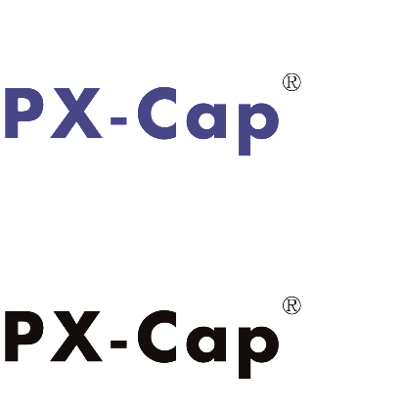

**█ Structure and Basic Characteristics of PXT Series Products**

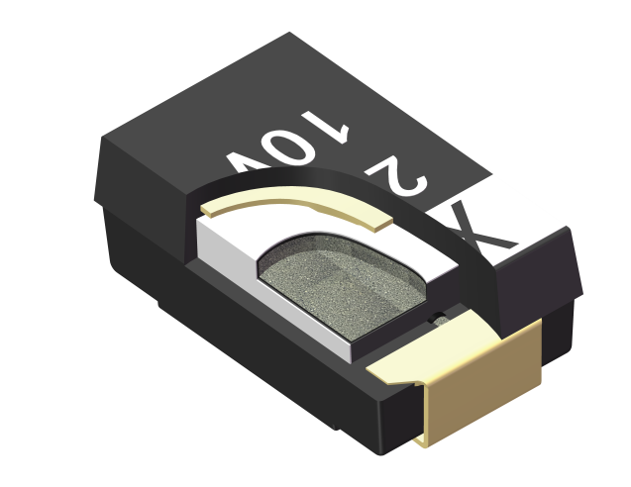

Encapsulated resin

Lead Frame

（- Cathode）

Lead Frame

（+ Anode）

Tantalum

Silver Paint



Anode of Ta

Ta2O5

Organic polymer

Carbon

Silver Paint

Fig.1 The Construction of PX-Cap

PX-Cap（organic polymer tantalum electrolytic capacitor）electrolytic capacitor has the same structure as the conventional chip tantalum electrolytic capacitor, but PX-Cap uses conductive organic polymer as the cathode of capacitor and connects with Ta2O5 dielectric layer. Because organic conductive polymer has excellent conductivity and good adhesion with dielectric layer, PX-Cap tantalum electrolytic capacitor has ultra-low ESR. And excellent temperature performance.

PX-Cap can choose gold-plated lead terminals to bring better storage performance and excellent solderability.

102

101

100

10-1

Conductive Polymer

TCNQ

（Organic Semiconductor）

Manganese dioxide

（MnO2）

Electrolyte

电导率（S・m-1）

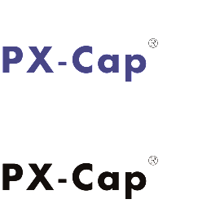

10-2

Fig. 2 Conductivity Diagram of Typical Cathode Materials of Capacitors

**█ Tape & Reel Packaging Information**



Fig.3 Packing Tape and Reel of PX-Cap

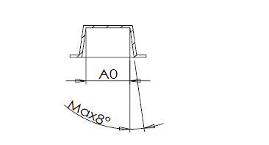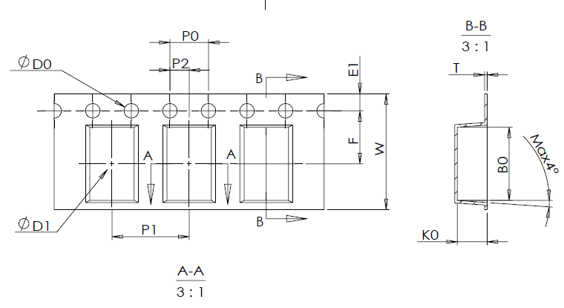

Fig.4 Package Size of PX-Cap

**█**  Tape Dimensions Unit：mm

|  |  |  |  |  |  |  |  |  |  |  |  |  |
| --- | --- | --- | --- | --- | --- | --- | --- | --- | --- | --- | --- | --- |
|  | W  (+0.30,-0.10) | P1  ±0.10 | E1  ±0.10 | F  ±0.10 | D0  ±0.10 | P0  ±0.10 | P010  ±0.10 | P2  ±0.10 | A0  ±0.10 | B0  ±0.10 | K0  ±0.10 | T  ±0.10 |
| B SIZE | 8.00 | 4.00 | 1.75 | 3.50 | 1.50 | 4.00 | 40.00 | 2.00 | 3.20 | 3.83 | 2.17 | 0.229 |
| L SIZE | 12.00 | 8.00 | 1.75 | 5.50 | 1.50 | 4.00 | 40.00 | 2.00 | 4.60 | 7.60 | 2.16 | 0.23 |
| D SIZE | 12.00 | 8.00 | 1.75 | 5.50 | 1.50 | 4.00 | 40.00 | 2.00 | 4.60 | 7.60 | 3.10 | 0.26 |
| E SIZE | 12.00 | 8.00 | 1.75 | 5.50 | 1.50 | 4.00 | 40.00 | 2.00 | 4.60 | 7.60 | 4.20 | 0.26 |

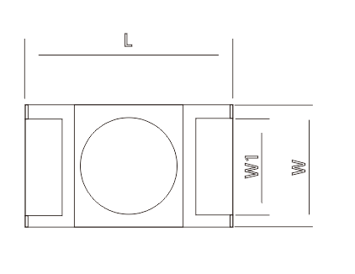**█** Case Dimensions Unit：mm

|  |  |  |  |  |  |
| --- | --- | --- | --- | --- | --- |
| Case | L±0.3 | W±0.3 | H±0.3 | W1±0.1 | L1±0.2 |
| B | 3.5 | 2.8 | 1.9 | 2.2 | 0.8 |
| L | 7.3 | 4.3 | 1.9 | 2.4 | 1.3 |
| D | 7.3 | 4.3 | 2.8 | 2.4 | 1.3 |
| E | 7.3 | 4.3 | 3.8 | 2.4 | 1.3 |

**█ Marking**

**【PXT Series】**

Rated Voltage

Capacitance Value

477 A

Y

Production Date

028

X

Polarity Indicator(+)

**【PXH Series】\***

Rated Voltage

Capacitance Value

477 A

H

Production Date

028

X

Polarity Indicator(+)

Fig.5. The Marking of PX-Cap

NOTE：* is the temporary remark style.

**How To Order**

**PXT B 006 M 107 E035 S T U**

**Additional characters: U=Universal**

**Lead termination：T=Sn，A=Au**

**Pellet number：S=Single，M=multiple**

**ESR code: E035=35mΩ**

**Capacitance code：107=100μF**

**Capacitance tolerance：M=20%，K=10%**

**Case size： B,L,D ,E**

**Rate voltage：2R5,004,006,008,010 etc.**

**Capacitors series：PXT, PXH**

Fig.6. Ordering Information

**Capacitance and Rated Voltage Range**

|  |  |  |  |  |  |  |  |  |  |
| --- | --- | --- | --- | --- | --- | --- | --- | --- | --- |
|  | 系列 | 2.5V | 4V | 6.3V | 10V | 16V | 20V | 25V | 35V |
| 10μF | PXT |  |  |  |  |  |  |  | E*4 |
| PXH |  |  |  |  |  |  |  |  |
| 22μF | PXT |  |  |  |  |  |  | E*4 | E*4 |
| PXH |  |  |  |  |  |  |  |  |
| 33μF | PXT |  |  |  |  |  |  | E*4 |  |
| PXH |  |  |  |  |  |  |  |  |
| 47μF | PXT |  |  |  |  |  |  | E*4 | E*4 |
| PXH |  |  |  |  |  |  |  |  |
| 68μF | PXT |  |  |  | L |  |  |  |  |
| PXH |  |  |  |  |  |  |  |  |
| 100μF | PXT |  |  | B、L | L、D | D、E*4 | E*4 |  |  |
| PXH |  |  | L | D |  |  |  |  |
| 150μF | PXT |  | B、L | B、L、D | D |  |  |  |  |
| PXH |  | B、L | D | E |  |  |  |  |
| 220μF | PXT | B、L | L、D | B、L、D | D | E*4 |  |  |  |
| PXH | L | D | D | E |  |  |  |  |
| 330μF | PXT | B、L | L、D | L、D | E |  |  |  |  |
| PXH | L | D | E |  |  |  |  |  |
| 470μF | PXT | L | D、E | E |  |  |  |  |  |
| PXH | D | E |  |  |  |  |  |  |
| 680μF | PXT | D | E | E |  |  |  |  |  |
| PXH |  |  |  |  |  |  |  |  |
| 1000μF | PXT | E | E |  |  |  |  |  |  |
| PXH |  |  |  |  |  |  |  |  |
| 1500μF | PXT | E |  |  |  |  |  |  |  |
| PXH |  |  |  |  |  |  |  |  |

NOTE: *4 ─custom-made product

**█ Performance Characteristic of PXT Series**

Tab2： Performance Characteristic of PXT Series

|  |  |  |  |  |  |
| --- | --- | --- | --- | --- | --- |
| **Item** | | **Performance** | | | **Test Conditions** |
| Operating temperature | | -55℃～105℃ | | | ― |
| Rated temperature | | 105℃ | | | ― |
| Rated voltage | | 2.5V~35V | | | Temperature： 105℃ |
| Surge voltage | | 1.15*Rated Voltage | | | Temperature： 105℃ |
| Tolerance | | 10μF ～ 1500μF | | | Test frequency：120Hz  Test voltage：0.5Vrms DC |
| Capacitance tolerance | | ±20％, ±10％ | | | Test frequency：120Hz  Test voltage：0.5Vrms DC |
| Tangent of loss angle（tanδ） | | Refer to Specification Table | | | Test frequency：120Hz  Test voltage：0.5Vrms DC |
| Leakage current | | Refer to Specification Table | | | Five minutes after rated voltage charging. |
| ESR | | Refer to Specification Table | | | Test frequency：100KHz  （Partial Spec Coding 300KHz～500KHz） |
| Ripple current | | Refer to Specification Table | | | Frequency：100kHz Sine Wave，45°  （Partial Spec Coding 300KHz ～ 500KHz） |
|  | | ΔC/C | tanδ | LC |  |
| Surge voltage test | | Below ±20% of initial specification | Below initial specification | Less than three times the initial specification |  |
| Temperature characteristic | +25℃ | ￣ | Within Specification Specification | Within Specification Specification |  |
| -55℃ | Below ±20% of initial specification | Below the initial specification | ￣ |
| +105℃ | +50%~0% relative initial specification | Less than 1.5 times the initial specification | Less than 10 times of the initial specification |
| Durability | | Below ±20% of initial specification | Less than 5times the initial specification | Below initial specification | Temperature：105℃  Voltage：Rated voltage  Time：2000 hours |
| Humidity resistance | | Within +40% (+ 50%*6)、-20% of the specification before test | Less than 1.5 times the specification before test | Less than 3 times the specification before test | Temperature：60℃  Humidity：90%～95%RH  Time：500 hours |

Note: *6 Some specifications are + 50%。

**█ Performance Characteristic of PXH Series**

Tab2： Performance Characteristic of PXH Series

|  |  |  |  |  |  |
| --- | --- | --- | --- | --- | --- |
| **Item** | | **Performance** | | | **Test Conditions** |
| Operating temperature | | -55℃～125℃ | | | ― |
| Rated temperature | | 125℃ | | | ― |
| Rated voltage | | 2.5~10.0 | | | Temperature： 125℃ |
| Surge voltage | | 1.15*Rated Voltage | | | Temperature： 125℃ |
| Tolerance | | 68μF～470μF | | | Test frequency：120Hz  Test voltage：0.5Vrms DC |
| Capacitance tolerance | | ±20％；±10% | | | Test frequency：120Hz  Test voltage：0.5Vrms DC |
| Tangent of loss angle（tanδ） | | Refer to Specification Table | | | Test frequency：120Hz  Test voltage：0.5Vrms DC |
| Leakage current | | Refer to Specification Table | | | Five minutes after rated voltage charging. |
| ESR | | Refer to Specification Table | | | Test frequency：100KHz  （Partial Spec Coding 300KHz～500KHz） |
| Ripple current | | Refer to Specification Table | | | Frequency：100kHz Sine Wave，45°  （Partial Spec Coding 300KHz ～ 500KHz） |
|  | | ΔC/C | tanδ | LC |  |
| Surge voltage test | | Below ±20% of initial specification | Below initial specification | Less than three times the initial specification |  |
| Temperature characteristic | +25℃ | ￣ | Within Specification Specification | Within Specification Specification |  |
| -55℃ | Below ±20% of initial specification | Below the initial specification | ￣ |
| +105℃ | +50%~0% relative initial specification | Less than 1.5 times the initial specification | Less than 10 times the initial specification |
| Durability | | Below ±20% of initial specification | Less than 5 times the initial specification | Below initial specification | Temperature：125℃  Voltage：Rated voltage  Time：1000 hours |
| Humidity resistance | | Within +40% (+ 50%*6)、-20% of the specification before test | Less than 1.5 times the specification before test | Less than 3 times the specification before test | Temperature：60℃  Humidity：90%～95%RH  Time：500 hours |

Note: *6 Some specifications are + 50%。

* **Specification of** **PXT Series**

|  |  |  |  |  |  |  |  |  |
| --- | --- | --- | --- | --- | --- | --- | --- | --- |
| Rated voltage  （V） | Capacitance  （μF） | Case | Specification code | Rated  Temperature  （℃） | LC（μA，+25℃） | tanδ  （+25℃  ,120Hz） | ESR  （mΩ，+25℃  ，100KHz） | Max ripple current  （mArms）  100KHz，45℃） |
| 2.5 | 220 | B | PXTB2R5M227E055SAU | 85 | 55 | 8 | 55 | 1200 |
| 220 | B | PXTB2R5M227E035SAU | 85 | 55 | 8 | 35 | 1400 |
| 220 | L | PXTL2R5M227E015SAU | 105 | 55 | 10 | 15 | 2800 |
| 220 | L | PXTL2R5M227E012SAU | 105 | 55 | 10 | 12 | 3100 |
| 330 | B | PXTB2R5M337E055SAU | 85 | 82.5 | 8 | 55 | 1400 |
| 330 | B | PXTB2R5M337E035SAU | 85 | 82.5 | 8 | 35 | 1400 |
| 330 | B | PXTB2R5M337E015SAU | 85 | 82.5 | 8 | 15 | 2000 |
| 330 | L | PXTL2R5M337E015SAU | 105 | 82.5 | 10 | 15 | 2800 |
| 330 | L | PXTL2R5M337E012SAU | 105 | 82.5 | 10 | 12 | 3100 |
| 330 | L | PXTL2R5M337E009SAU | 105 | 82.5 | 10 | 9 | 3500 |
| 470 | L | PXTL2R5M477E015SAU | 105 | 117.5 | 10 | 15 | 2800 |
| 470 | L | PXTL2R5M477E012SAU | 105 | 117.5 | 10 | 12 | 3100 |
| 470 | L | PXTL2R5M477E009SAU | 105 | 117.5 | 10 | 9 | 3500 |
| 680 | D | PXTD2R5M687E025SAU | 105 | 170 | 10 | 25 | 2400 |
| 680 | D | PXTD2R5M687E015SAU | 105 | 170 | 10 | 15 | 2800 |
| 1000 | E | PXTE2R5M108E025SAU | 105 | 250 | 10 | 25 | 3000 |
| 1000 | E | PXTE2R5M108E015SAU | 105 | 250 | 10 | 15 | 3600 |
| 1500 | E | PXTE2R5M158E025SAU | 105 | 375 | 10 | 25 | 3000 |
| 1500 | E | PXTE2R5M158E015SAU | 105 | 375 | 10 | 15 | 3600 |
| 4 | 150 | B | PXTB004M157E035SAU | 85 | 60 | 8 | 35 | 1400 |
| 150 | L | PXTL004M157E025SAU | 105 | 60 | 10 | 25 | 2800 |
| 220 | L | PXTL004M227E040SAU | 105 | 88 | 10 | 40 | 1900 |
| 220 | L | PXTL004M227E025SAU | 105 | 88 | 10 | 25 | 2400 |
| 220 | L | PXTL004M227E015SAU | 105 | 88 | 10 | 15 | 2800 |
| 220 | D | PXTD004M227E040SAU | 105 | 88 | 10 | 40 | 1900 |
| 330 | L | PXTL004M337E025SAU | 105 | 132 | 10 | 25 | 2400 |
| 330 | L | PXTL004M337E018SAU | 105 | 132 | 10 | 18 | 2600 |
| 330 | D | PXTD004M337E040SAU | 105 | 132 | 10 | 40 | 1900 |
| 470 | D | PXTD004M477E040SAU | 105 | 188 | 10 | 40 | 1900 |
| 470 | D | PXTD004M477E018SAU | 105 | 188 | 10 | 18 | 2600 |
| 470 | D | PXTD004M477E015SAU | 105 | 188 | 10 | 15 | 2800 |
| 470 | D | PXTD004M477E012SAU | 105 | 188 | 10 | 12 | 3100 |
| 470 | E | PXTE004M477E018SAU | 105 | 188 | 10 | 18 | 3400 |
| 470 | E | PXTE004M477E015SAU | 105 | 188 | 10 | 15 | 3600 |
| 680 | E | PXTE004M687E025SAU | 105 | 272 | 10 | 25 | 3000 |
| 680 | E | PXTE004M687E015SAU | 105 | 272 | 10 | 15 | 3600 |
| 1000 | E | PXTE004M108E025SAU | 105 | 400 | 10 | 25 | 3000 |

■ **Specification of** **PXT Series**

|  |  |  |  |  |  |  |  |  |
| --- | --- | --- | --- | --- | --- | --- | --- | --- |
| Rated voltage  （V） | Capacitance  （μF） | Case | Specification code | Rated  temperature  （℃） | LC（μA，+25℃） | tanδ  （+25℃  ,120Hz） | ESR  （mΩ，+25℃  ，100KHz） | Max ripple current  （mArms）  100KHz，45℃） |
| 6.3 | 100 | B | PXTB006M107E055SAU | 85 | 63 | 8 | 55 | 1200 |
| 100 | B | PXTB006M107E035SAU | 85 | 63 | 8 | 35 | 1400 |
| 100 | L | PXTL006M107E045SAU | 105 | 63 | 10 | 45 | 1700 |
| 100 | L | PXTL006M107E025SAU | 105 | 63 | 10 | 25 | 2400 |
| 100 | L | PXTL006M107E018SAU | 105 | 63 | 10 | 18 | 2600 |
| 150 | B | PXTB006M157E035SAU | 85 | 94.5 | 8 | 35 | 1400 |
| 150 | L | PXTL006M157E025SAU | 105 | 94.5 | 10 | 25 | 2400 |
| 150 | L | PXTL006M157E015SAU | 105 | 94.5 | 10 | 15 | 2800 |
| 150 | D | PXTD006M157E040SAU | 105 | 94.5 | 10 | 40 | 1900 |
| 220 | B | PXTB006M227E055SAU | 85 | 138.6 | 8 | 55 | 1200 |
| 220 | B | PXTB006M227E035SAU | 85 | 138.6 | 8 | 35 | 1400 |
| 220 | L | PXTL006M227E025SAU | 105 | 138.6 | 10 | 25 | 2400 |
| 220 | L | PXTL006M227E018SAU | 105 | 138.6 | 10 | 18 | 2600 |
| 220 | D | PXTD006M227E040SAU | 105 | 138.6 | 10 | 40 | 1900 |
| 330 | L | PXTL006M337E025SAU | 85 | 207.9 | 10 | 25 | 2400 |
| 330 | D | PXTD006M337E040SAU | 105 | 207.9 | 10 | 40 | 1900 |
| 330 | D | PXTD006M337E025SAU | 105 | 207.9 | 10 | 25 | 2400 |
| 330 | D | PXTD006M337E018SAU | 105 | 207.9 | 10 | 18 | 2600 |
| 330 | D | PXTD006M337E015SAU | 105 | 207.9 | 10 | 15 | 2800 |
| 470 | E | PXTE006M477E025SAU | 105 | 296.1 | 10 | 25 | 3000 |
| 470 | E | PXTE006M477E018SAU | 105 | 296.1 | 10 | 18 | 3400 |
| 680 | E | PXTE006M687E025SAU | 105 | 428.4 | 10 | 25 | 3000 |
| 680 | E | PXTE006M687E018SAU | 105 | 428.4 | 10 | 18 | 3400 |
| 10 | 68 | L | PXTL010M686E045SAU | 105 | 68 | 10 | 45 | 1700 |
| 68 | L | PXTL010M686E025SAU | 105 | 68 | 10 | 25 | 2400 |
| 100 | L | PXTL010M107E045SAU | 105 | 100 | 10 | 45 | 1700 |
| 100 | D | PXTD010M107E045SAU | 105 | 100 | 10 | 45 | 1700 |
| 150 | D | PXTD010M157E040SAU | 105 | 150 | 10 | 40 | 1900 |
| 220 | D | PXTD010M227E040SAU | 105 | 220 | 10 | 40 | 1900 |
| 220 | D | PXTD010M227E025SAU | 105 | 220 | 10 | 25 | 2400 |
| 220 | D | PXTD010M227E018SAU | 105 | 220 | 10 | 18 | 2600 |
| 330 | E | PXTE010M337E025SAU | 105 | 330 | 10 | 25 | 3000 |
| 470 | E | PXTE010M477E040SAU | 105 | 470 | 10 | 40 | 1900 |
| 470 | E | PXTE010M477E025SAU | 105 | 470 | 10 | 25 | 3000 |

Note：The products show in the list are all gold-plated terminations, Tin-plated terminations are available for most of the products in the list.

■ **Specification of** **PXH Series**

|  |  |  |  |  |  |  |  |  |
| --- | --- | --- | --- | --- | --- | --- | --- | --- |
| Rated voltage  （V） | Capacitance  （μF） | Case | Specification code | Rated  Temperature  （℃） | LC（μA，+25℃） | tanδ  （+25℃  ,120Hz） | ESR  （mΩ，+25℃  ，100KHz） | Max ripple current  （mArms）  100KHz，45℃） |
| 2.5 | 220 | L | PXHL2R5M227E018SAU | 125 | 55 | 10 | 18 | 2800 |
| 330 | L | PXHL2R5M337E018SAU | 125 | 82.5 | 10 | 18 | 2800 |
| 470 | D | PXHD2R5M477E025SAU | 125 | 117.5 | 10 | 25 | 2400 |
| 4 | 150 | B | PXHB004M157E035SAU | 125 | 60 | 8 | 35 | 1400 |
| 220 | B | PXHB004M227E035SAU | 125 | 88 | 8 | 35 | 1400 |
| 150 | L | PXHL004M157E025SAU | 125 | 60 | 10 | 25 | 2400 |
| 220 | D | PXHD004M227E040SAU | 125 | 88 | 10 | 40 | 1900 |
| 330 | D | PXHD004M337E040SAU | 125 | 132 | 10 | 40 | 1900 |
| 470 | E | PXHE004M477E025SAU | 125 | 188 | 10 | 25 | 2800 |
| 6.3 | 100 | L | PXHL006M107E045SAU | 125 | 63 | 10 | 45 | 1900 |
| 150 | D | PXHD006M157E040SAU | 125 | 94.5 | 10 | 40 | 2400 |
| 220 | D | PXHD006M227E040SAU | 125 | 138.6 | 10 | 40 | 2400 |
| 330 | E | PXHE006M337E040SAU | 125 | 207.9 | 10 | 40 | 1900 |
| 10 | 100 | D | PXHD010M107E045SAU | 125 | 100 | 10 | 45 | 1700 |
| 220 | E | PXHE010M227E025SAU | 125 | 220 | 10 | 25 | 2800 |

Note：The products show in the list are all gold-plated terminations, Tin-plated terminations are available for most of the products in the list.

■ **PX CAP Soldering Process**

（1）Recommended pad pattern and size

Tab：pad size

|  |  |  |  |
| --- | --- | --- | --- |
| Case | X  （mm） | Y  （mm） | Z  （mm） |
| B | 1.6 | 2.7 | 1.4 |
| L、D、E | 2.4 | 2.9 | 3.7 |

Z

X

Y

X

（2）Recommended reflow temperature

When soldering with soldering iron, soldering iron should be used below 30W, the temperature of soldering iron tip should be less than 350 ℃, and the operating time should be less than 3 seconds.  
 (Never touch or exert strong force on the capacitor body with a soldering iron tip.)

When reflow soldering is used, refer to the recommended soldering curve as follows.

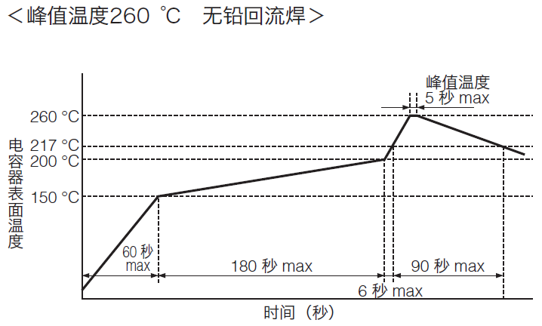

Fig.8 Recommended Reflow Soldering Curve of PX-Cap

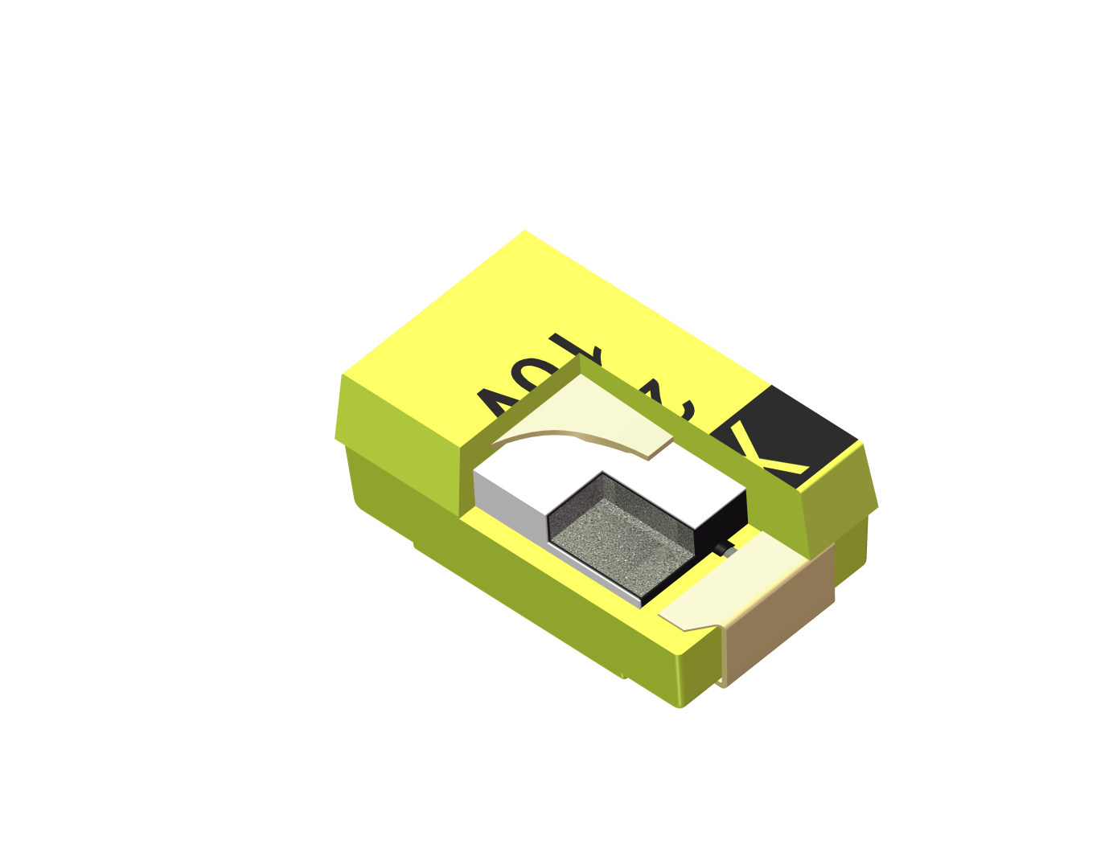

■ **Structural Diagram and Introduction of CA45 Series**

1. Product Structure Diagram

Encapsulated resin

Silver Paint



Anode of Ta or Nb

MnO2

Carbon

Silver Paint

Lead Frame

（- Cathode）

Ta2O5 or Nb2O5

Tantalum or Niobium

Lead Frame

（+ Anode）

Fig.9 Structural of CA45 Series

CA45 series capacitors use tantalum as Anode. A dielectric film is formed on the surface of tantalum particles by special process. Conductive manganese dioxide is deposited outside the dielectric film by decomposition process as the negative electrode of the capacitor and is extracted by carbon and silver slurry. And then forming the capacitor with large capacitance in small volume.

According to the difference of ESR,CA45 series is divided into CA45 series, CA45A series, CA45B (series low ESR) and CA45U series(ultra low ESR).

CN45 series showing better ability in resisting RMS and surge voltage, almost can work at rated voltage. Even if after dielectric breakdown, the capacitor still keep non burn.

104

103

102

101

Conductive Polymer

TCNQ

（Organic Semiconductor）

Manganese dioxide

（MnO2）

Electorlyte

Conductivity（S・m-1）

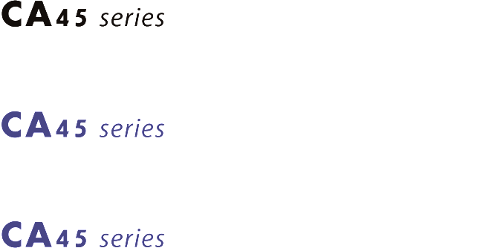

Fig.10 Typical Electrolyte Conductivity Diagram

■ **Tape & Reel Packaging Information**

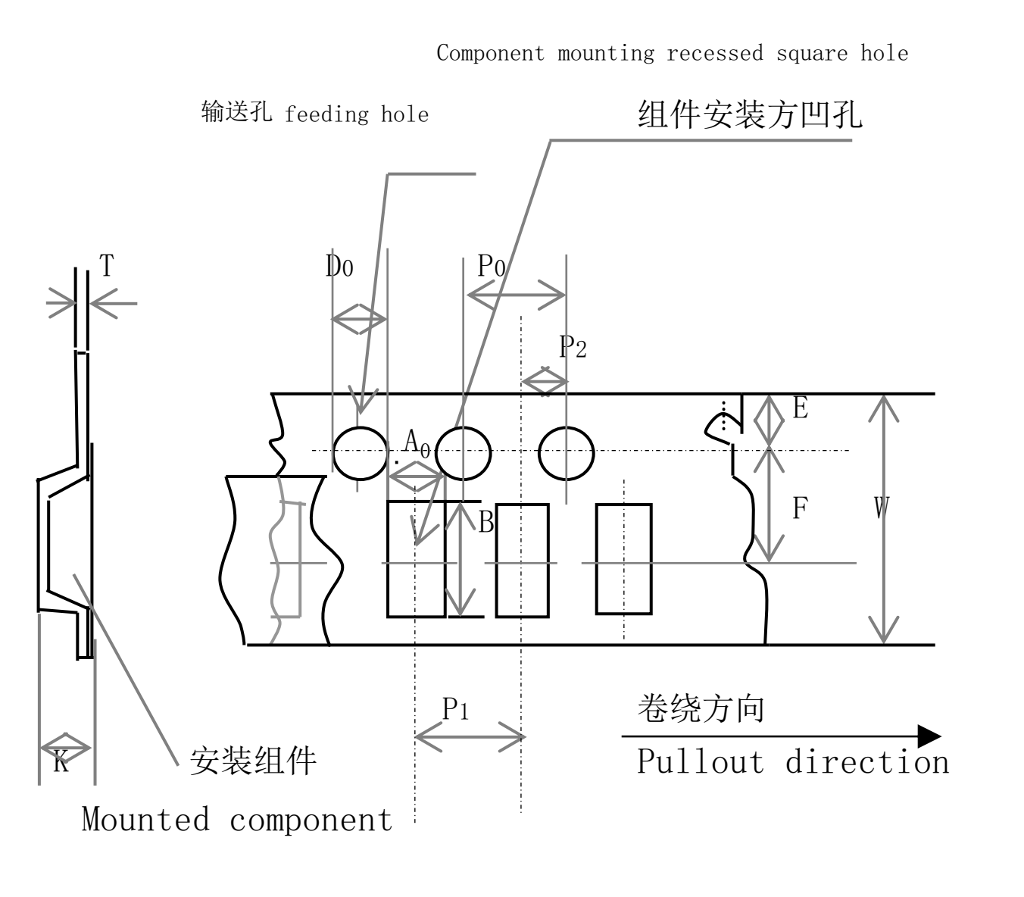

Fig.11 CA45 Series Packaging Tape

Tab：Detailed Size of Packing Tape

|  |  |  |  |  |  |  |  |  |  |  |  |
| --- | --- | --- | --- | --- | --- | --- | --- | --- | --- | --- | --- |
|  |  |  |  |  |  |  |  |  |  |  | Unit:mm |
| Size code | A0±0.2 | B0±0.2 | K±0.2 | W±0.3 tape width | F±0.1 | P1±0.1 pitch of component | E±0.1 | P2±0.1 | P0±0.1 Feed hole pitch | D0 Feed hole diameter | T |
|
|
| P | 1.4 | 2.2 | 1.2 | 8 | 3.5 | 4 | 1.75 | 2 | 4 | 1.5 | 0.2~0.3 |
| A | 1.9 | 3.5 | 1.9 |
| B | 3.1 | 3.8 | 2.1 |
| C | 3.7 | 6.4 | 2.9 | 12 | 5.5 |
| D/E | 4.8 | 7.7 | 3.2 | 5.7 | 8 |

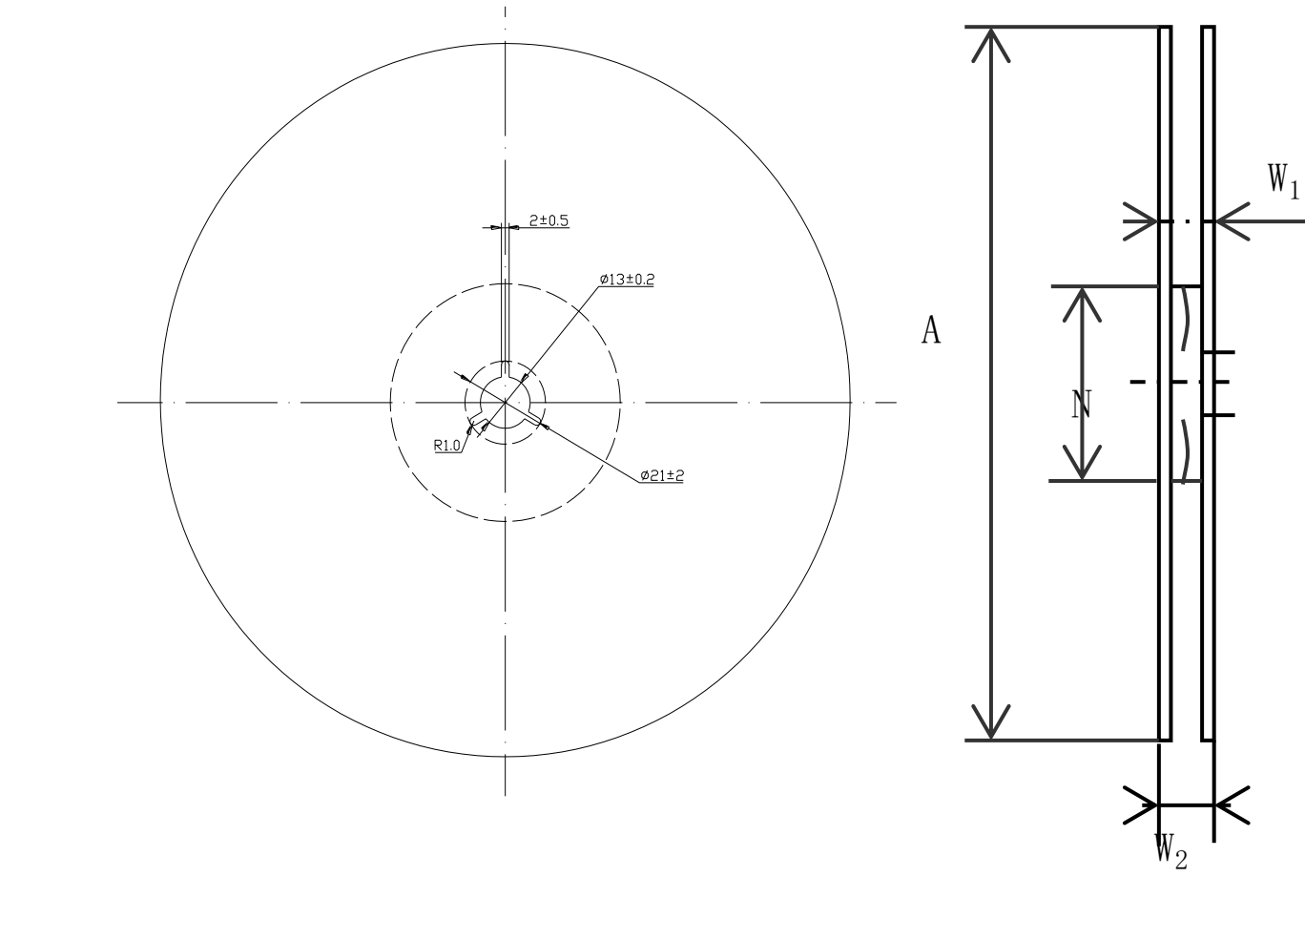

Fig.12 Diagram And Size of CA45 Series Tape

**█ Performance Characteristic of CA45 Series**

|  |  |  |  |  |  |
| --- | --- | --- | --- | --- | --- |
| **Item** | | **Performance** | | | **Test Conditions** |
| Operating temperature | | -55℃　～　125℃ | | | Above 85℃, use derated voltage |
| Rated voltage | | 2.5V ~ 50V  4.0  6.3  10.0 | | |  |
| Surge voltage | | Refer to List of Surge Voltage | | | Temperature:85℃ |
| Capacitance | | 0.1μF　～　1000μF | | | Test frequency：120Hz |
| Capacitance tolerance | | ±20％，±10％ | | | Test frequency：120Hz |
| Tangent of loss angle（tanδ） | | Refer to Spec Coding and Spec Table Specification Table | | | Test frequency：120Hz |
| LC | | Refer to Spec Coding and Spec Table | | | Five minutes after rated voltage charging |
| ESR | | Refer to Spec Coding and Spec Table | | | Test frequency：100KHz |
|  | | ΔC/C | tanδ | LC |  |
| Surge voltage test | | Lower than 10% initial specification | Below the initial specification | Below the initial specification |  |
| Chanracterastic of temperature | -55℃ | ±10% or±12％*1 | Lower than 1.5 times initial specification |  |  |
| +85℃ | Relative initial specification | Lower than 1.5 times initial specification | Lower than 10 times initial specification |
| +125℃ | ±10% or ±12％，±20％*1 | Lower than 1.2 times initial specification | Lower than 12.5 times initial specification |
| Temperature cycle | | Lower than 10% initial specification | Lower than 1.5 times initial specification | Lower than specification | -55℃~+125℃  5 cycle |
| Resistance to soldering heat | | Lower than 10% initial specification | Lower than the specification before test | Lower than the specification before test | Solder dip：260℃ 10 second |
| Solder reflow：Tmax=260℃ |
| Damp | | ±20% | Lower than 1.5 times initial specification | Lower than initial specification | 40℃ 90~95%RH  500h |
| Endurance | | ±10% | Lower than initial specification | Lower than initial specification | 85℃：Rated voltage 2000h  125℃：Reduced voltage 2000h |
| Failure rate | | λ0=1%/1000hrs | | |  |

Note：*1 Some specifications may be different, please consult our company for details.

■ **CA45 Series Surge Voltage**

|  |  |  |  |  |  |  |  |  |  |  |
| --- | --- | --- | --- | --- | --- | --- | --- | --- | --- | --- |
| Rated voltage(V) | | 2.5 | 4 | 6.3 | 10 | 16 | 20 | 25 | 35 | 50 |
| Category voltage (V) | | 1.6 | 2.5 | 4 | 6.3 | 10 | 13 | 16 | 20 | 32 |
| Surge voltage | 85℃ | 2.8 | 5 | 7 | 12 | 18 | 23 | 29 | 40 | 57 |
| (V) | 125℃ | 1.8 | 3 | 5 | 7 | 12 | 15 | 18 | 23 | 37 |

■**CA45 Series Capacitance and Rated Voltage Range**

|  |  |  |  |  |  |  |  |  |  |
| --- | --- | --- | --- | --- | --- | --- | --- | --- | --- |
| UR（Ｖ）  Cap（μＦ） | 2.5 | 4 | 6.3 | 10 | 16 | 20 | 25 | 35 | 50 |
| 0.1 |  |  |  |  |  | P | P | P/A | A |
| 0.15 |  |  |  |  |  | P | P/A | P/A | A/B |
| 0.22 |  |  |  |  |  | P | P | P/A | A/B |
| 0.33 |  |  |  |  |  | P | P/A | P/A | A/B |
| 0.47 |  |  |  |  |  | P | P/A | P/A/B | A/B/C |
| 0.68 |  |  |  |  | A | P/A | P/A | A/B | A/B/C |
| 1.0 |  |  |  |  | P/A | P/A | P/A/B | A/B | B/C |
| 1.5 |  |  |  | P/A | P/A | P/A | A/B | A/B/C | B/C/D |
| 2.2 |  |  | P/A | P/A/B | P/A | P/A/B | A/B/C | A/B/C | B/C/D |
| 3.3 |  | P/A | P/A | P/A/B | P/A/B | A/B | A/B/C | B/C | C/D |
| 4.7 |  | P/A | P/A | P/A/B/C | A/B/C | A/B/C | A/B/C | B/C/D | C/D/E |
| 6.8 |  | P/A | P/A/B | P/A/B | A/B/C | A/B/C | B/C | C/D | D/E |
| 10 |  | P/A/B | P/A/B | P/A/B/C | A/B/C | B/C | B/C/D | C/D/E | D/E |
| 15 | P | P/A/B | A/B/C | A/B/C | A/B/C | B/C/D | C/D | D/E | D/E |
| 22 | P | P/A/B/C | A/B/C | A/B/C | A/B/C/D | B/C/D | C/D | D/E | E |
| 33 | P | P/A/B/C | A/B/C | B/C/D | B/C/D | C/D | D/E | D/E |  |
| 47 |  | A/B/C | A/B/C/D | B/C/D | B/C/D | C/D/E | D/E | E |  |
| 68 |  | A/B/C/D | A/B/C/D | B/C/D | C/D | D/E | D/E |  |  |
| 100 |  | A/B/C/D | B/C/D | B/C/D/E | C/D/E | D/E | E |  |  |
| 150 |  | B/C/D | B/C/D | C/D/E | D/E | E |  |  |  |
| 220 |  | B/C/D | C/D/E | D/E | E | E |  |  |  |
| 330 |  | C/D/E | C/D/E | D/E | E |  |  |  |  |
| 470 |  | D/E | D/E | E |  |  |  |  |  |
| 680 |  | D/E | E |  |  |  |  |  |  |
| 1000 |  | E |  |  |  |  |  |  |  |

■**CN45 Series Capacitance and Rated Voltage Range**

|  |  |  |  |  |
| --- | --- | --- | --- | --- |
| 额定电压（Ｖ）  容量（μＦ） | 2.5 | 4 | 6.3 | 10 |
| 4.7 |  |  | A* | A* |
| 6.8 |  |  | A* | A* |
| 10 |  |  | A* | A*/B |
| 15 |  | A* | A*/B | A*/B |
| 22 | A* | A*/B | A*/B | B/C* |
| 33 | A*/B | A*/B | B/C* | C* |
| 47 | A*/B | A*/B/C* | B/C* | C* |
| 68 | B/C* | B/C* | B/C* | C* |
| 100 | B/C* | B/C* | B/C*/D* | D* |
| 150 | C* | C*/D* | C*/D* |  |
| 220 | C* | C*/D* | C*/D*/E* |  |
| 330 | C*/D* | D* | D*/E* |  |
| 470 | D*/E* | D*/E* | E* |  |
| 680 | E* | E* |  |  |

Note:* means in developing

■ **CA45 Series Ordering Information**



Fig.13 CA45 Series ordering information

■ **MX-CAP Marking**

【B，C，D，E Case】 【A Case】

Example：20V 10μF Example：20V 1μF

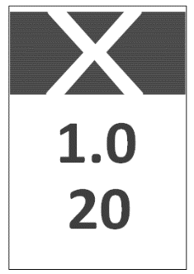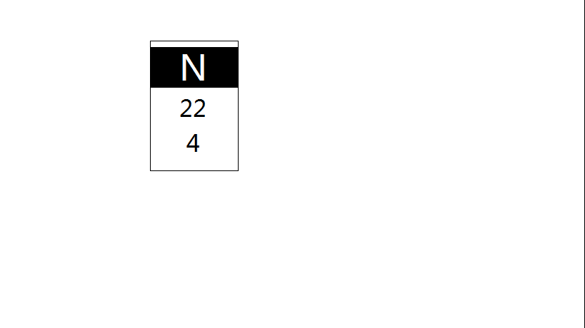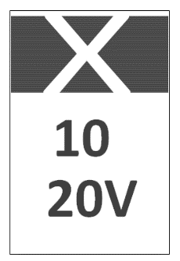

Polarity

Indicator(+)

Indicator(+)

Capacitance（μF）

Rated Volatage

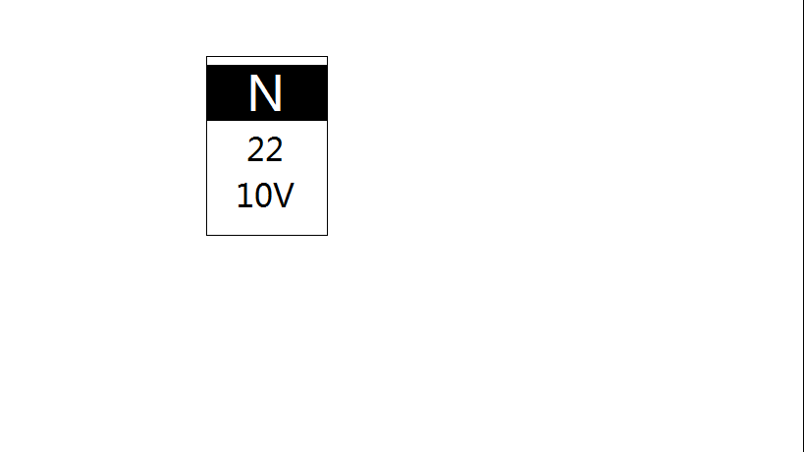

Polarity

Indicator(+)

Indicator(+)

Capacitance（μF）

Rated Volatage

【P Case】 Example：6.3V 4.7μF

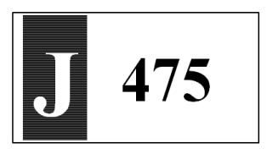

Positive polarity and voltage logo

Capacitance value

Fig.14 MX-CAP M arking

Tab：Rated voltage and capacitance code of case P

Rated

voltage

Voltage

Capacitance

（μF）

0.1

0.15

0.22

0.33

0.47

0.68

1

1.5

2.2

3.3

4.7

6.8

10

15

22

33

Capacitance

104

154

224

334

474

684

105

155

225

335

475

685

106

156

226

336

20 V

D

25 V

E

35 V

e

G

J

A

C

V

2.5 V

4 V

6.3 V

10 V

16 V

code

code

Tab. Case Dimensions

|  |  |  |  |  |  |  |  |
| --- | --- | --- | --- | --- | --- | --- | --- |
| Case | | Dimensions mm | | | | | |
| Xinyun | EIA | L | W | H | L1 | W1 | M |
| P | 2012-12 | 2.0±0.2 | 1.25±0.2 | 1.2±0.2 | 0.5 $\begin{matrix}0 \\ -0.1\end{matrix}$ | 0.9±0.1 | 0.7 $\begin{matrix}+0.1 \\ 0\end{matrix}$ |
| A | 3216-16 | 3.2±0.2 | 1.6±0.2 | 1.6±0.2 | 0.65±0.2 | 1.2±0.2 | 1.0±0.2 |
| B | 3528-19 | 3.5±0.2 | 2.8±0.2 | 1.9±0.2 | 0.70±0.2 | 2.0±0.2 | 1.2±0.2 |
| C | 6032-25 | 5.8±0.3 | 3.2±0.3 | 2.5±0.3 | 1.35±0.2 | 2.2±0.2 | 1.45±0.2 |
| D | 7343-28 | 7.3±0.3 | 4.3±0.3 | 2.8±0.3 | 1.35±0.2 | 3.0±0.2 | 1.6±0.2 |
| E | 7343-41 | 7.3±0.3 | 4.3±0.3 | 4.1±0.3 | 1.35±0.2 | 3.0±0.2 | 1.6±0.2 |

■ **MX-CAP Outline Diagram and Size of Case**

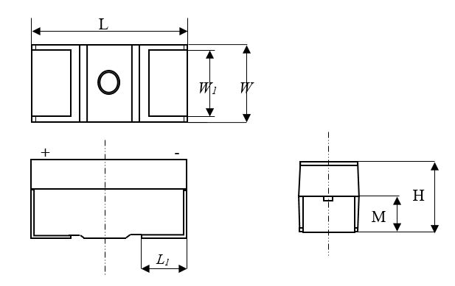

Note：The chip corresponding to the end of the factory sign in the product sign is positive pole.

Fig.15 CA45 Series Outline Size Diagram

* **Specification of** **CN45 Series**

|  |  |  |  |  |  |
| --- | --- | --- | --- | --- | --- |
| Rated voltage | Rated  capacitance | Case | ESR max | DCL max | Tan δ max |
| 100KHz +25℃ Ω | µA +25℃ | % +25℃ |
| 2.5 | 33 | B | 1.7 | 1.7 | 6 |
| 47 | B | 1.6 | 2.4 | 6 |
| 68 | B | 1.5 | 3.4 | 8 |
| 100 | B | 1.4 | 5 | 8 |
| 4 | 22 | B | 1.9 | 1.8 | 6 |
| 33 | B | 1.7 | 2.6 | 6 |
| 47 | B | 1.6 | 3.8 | 6 |
| 68 | B | 1.5 | 5.4 | 8 |
| 100 | B | 1.4 | 8 | 16 |
| 6.3 | 15 | B | 2 | 1.8 | 6 |
| 22 | B | 1.9 | 2.6 | 6 |
| 33 | B | 1.7 | 4 | 8 |
| 33 | B | 0.7 | 4 | 8 |
| 47 | B | 0.8 | 5.6 | 8 |
| 68 | B | 1.5 | 8.2 | 20 |
| 100 | B | 1.7 | 60 | 20 |
| 10 | 10 | B | 1 | 2 | 6 |
| 15 | B | 2 | 3 | 6 |
| 22 | B | 1.8 | 4.4 | 8 |
| 22 | B | 0.7 | 4.4 | 8 |

* **Specification of** **CA45 Series**

|  |  |  |  |  |  |  |  |  |
| --- | --- | --- | --- | --- | --- | --- | --- | --- |
| Rated voltage | Rated  capacitance | Case | ESR max 100KHz +25℃ Ω | | | | DCL max µA +25℃ | Tan δ max % +25℃ |
| CA45 | CA45A | CA45B | CA45U |
| 2.5V | 15 | P |  | 8 |  |  | 0.5 | 6 |
| 22 | P |  | 6 |  |  | 0.5 | 6 |
| 33 | P |  | 4 |  |  | 0.7 | 18 |
| 4V | 3.3 | A |  | 8 | 4 |  | 0.5 | 6 |
| 3.3 | P |  | 20 |  |  | 0.5 | 6 |
| 4.7 | A | 8 | 6 | 3.5 |  | 0.5 | 6 |
| 4.7 | P |  | 12 |  |  | 0.5 | 6 |
| 6.8 | A | 8 | 6 | 3 |  | 0.5 | 6 |
| 6.8 | P |  | 10 |  |  | 0.5 | 6 |
| 10 | B | 4 | 3.5 | 1.2 |  | 0.5 | 6 |
| 10 | A | 8 | 6 | 2 |  | 0.5 | 6 |
| 10 | P |  | 8 | 6 | 3 | 0.5 | 6 |
| 15 | B |  | 3.5 | 1.2 |  | 0.6 | 6 |
| 15 | A | 6 | 4 | 1.5 |  | 0.6 | 6 |
| 15 | P |  | 6 | 5.5 | 5 | 0.6 | 6 |
| 22 | C | 3.2 | 1.8 | 0.5 |  | 0.9 | 6 |
| 22 | B | 5 | 3.5 | 0.6 |  | 0.9 | 6 |
| 22 | A | 6 | 4 | 1.5 |  | 0.9 | 6 |
| 22 | P |  | 4 |  |  | 0.9 | 18 |
| 33 | C | 2.2 | 1.8 | 0.5 |  | 1.3 | 6 |
| 33 | B | 3.5 | 2.5 | 0.6 |  | 1.3 | 6 |
| 33 | A | 6 | 4 | 3 |  | 1.3 | 6 |
| 33 | P |  | 4 |  |  | 1.3 | 18 |
| 47 | C | 2 | 1 | 0.5 |  | 1.9 | 6 |
| 47 | B | 3 | 2 | 0.5 |  | 1.9 | 6 |
| 47 | A | 4 | 2.5 | 2 | 0.5 | 1.9 | 10 |
| 68 | D | 1.1 | 0.8 | 0.2 |  | 2.7 | 6 |
| 68 | C | 2 | 1.2 | 0.25 |  | 2.7 | 6 |
| 68 | B | 4.2 | 3.5 | 2 |  | 2.7 | 6 |
| 68 | A | 5 | 4 | 3 |  | 2.7 | 15 |
| 100 | D | 0.9 | 0.7 | 0.2 |  | 4 | 8 |
| 100 | C | 1.5 | 0.8 | 0.2 |  | 4 | 8 |
| 100 | B | 2 | 0.9 | 0.65 | 0.5 | 4 | 10 |
| 100 | A | 6 | 4 | 3 | 2.5 | 4 | 20 |
| 150 | D | 1 | 0.5 | 0.15 |  | 6 | 8 |

* **Specification of** **CA45 Series (Continued)**

|  |  |  |  |  |  |  |  |  |
| --- | --- | --- | --- | --- | --- | --- | --- | --- |
| Rated voltage | Rated  capacitance | Case | ESR max 100KHz +25℃ Ω | | | | DCL max µA +25℃ | Tan δ max % +25℃ |
| CA45 | CA45A | CA45B | CA45U |
| 4V | 150 | C | 1.5 | 1 | 0.2 | 0.1 | 6 | 8 |
| 150 | B | 3 | 2 | 1 | 0.5 | 6 | 12 |
| 220 | D | 1 | 0.5 | 0.15 | 0.1 | 8.8 | 8 |
| 220 | C | 1.5 | 1 | 0.3 |  | 8.8 | 8 |
| 220 | B | 2 | 1.1 | 0.4 | 0.3 | 8.8 | 15 |
| 330 | E | 0.7 | 0.5 | 0.15 | 0.1 | 13.2 | 10 |
| 330 | D | 0.9 | 0.5 | 0.15 | 0.1 | 13.2 | 10 |
| 330 | C | 1.7 | 0.9 | 0.3 | 0.15 | 13.2 | 10 |
| 330 | B |  | 1.5 | 0.3 |  | 13.2 | 18 |
| 470 | E | 0.7 | 0.5 | 0.15 | 0.1 | 18.8 | 10 |
| 470 | D | 0.7 | 0.5 | 0.15 | 0.1 | 18.8 | 10 |
| 680 | E | 0.7 | 0.5 | 0.1 |  | 27.2 | 12 |
| 680 | D | 0.7 | 0.5 | 0.15 | 0.1 | 27.2 | 14 |
| 1000 | E | 0.7 | 0.5 | 0.1 | 0.08 | 40 | 16 |
| 6.3V | 2.2 | A |  | 8 | 6 |  | 0.5 | 6 |
| 2.2 | P |  | 20 |  |  | 0.5 | 6 |
| 3.3 | A | 8 | 8 | 6 | 2.1 | 0.5 | 6 |
| 3.3 | P |  | 12 |  |  | 0.5 | 6 |
| 4.7 | A | 8 | 6 | 3.5 |  | 0.5 | 6 |
| 4.7 | P |  | 10 |  |  | 0.5 | 6 |
| 6.8 | B | 4.5 | 3.5 | 1.2 |  | 0.5 | 6 |
| 6.8 | A | 8 | 6 | 2 | 1.8 | 0.5 | 6 |
| 6.8 | P |  | 8 |  |  | 0.5 | 6 |
| 10 | B |  | 3.5 | 1 | 1.5 | 0.6 | 6 |
| 10 | A | 8 | 4 | 2 | 1.5 | 0.6 | 6 |
| 10 | P |  | 6 | 4 | 3 | 0.6 | 6 |
| 15 | C | 3 | 1.8 | 0.6 |  | 0.9 | 6 |
| 15 | B | 5 | 3.5 | 0.7 |  | 0.9 | 6 |
| 15 | A | 6 | 3.5 | 2 | 1.5 | 0.9 | 6 |
| 22 | C | 2.2 | 1.8 | 0.5 |  | 1.4 | 6 |
| 22 | B | 5 | 3.5 | 0.6 | 0.4 | 1.4 | 6 |
| 22 | A | 6 | 4 | 3 | 0.9 | 1.4 | 6 |
| 33 | C | 2.5 | 1.8 | 0.3 |  | 2.1 | 6 |
| 33 | B | 3.5 | 2.5 | 0.6 | 0.45 | 2.1 | 6 |
| 33 | A | 5 | 2.5 | 2 | 0.6 | 2.1 | 10 |
| 47 | D | 1.1 | 0.8 | 0.22 |  | 3 | 6 |

* **Specification of** **CA45 Series (Continued)**

|  |  |  |  |  |  |  |  |  |
| --- | --- | --- | --- | --- | --- | --- | --- | --- |
| Rated voltage | Rated  capacitance | Case | ESR max 100KHz +25℃ Ω | | | | DCL max µA +25℃ | Tan δ max % +25℃ |
| CA45 | CA45A | CA45B | CA45U |
| 6.3V | 47 | C | 2 | 1 | 0.25 |  | 3 | 6 |
| 47 | B | 3 | 2 | 0.5 | 0.35 | 3 | 6 |
| 47 | A | 5 | 3.5 | 2.5 | 0.8 | 3 | 12 |
| 68 | D | 0.9 | 0.8 | 0.2 |  | 4.3 | 6 |
| 68 | C | 2 | 1.2 | 0.25 | 0.2 | 4.3 | 6 |
| 68 | B | 1.5 | 0.9 | 0.65 | 0.5 | 4.3 | 8 |
| 68 | A |  | 4 | 3 | 1.5 | 4.3 | 18 |
| 100 | D | 1.2 | 0.7 | 0.15 |  | 6.3 | 8 |
| 100 | C | 1.5 | 0.9 | 0.3 | 0.15 | 6.3 | 8 |
| 100 | B | 5 | 3 | 1.5 | 0.4 | 6.3 | 15 |
| 100 | A |  | 3 | 2.5 | 1.5 | 6.3 | 18 |
| 150 | D | 1 | 0.5 | 0.15 | 0.125 | 9.5 | 8 |
| 150 | C | 1.5 | 1 | 0.3 | 0.25 | 9.5 | 8 |
| 150 | B | 2.8 | 2.5 | 1.5 | 0.8 | 9.5 | 20 |
| 220 | E | 0.7 | 0.5 | 0.15 |  | 13.9 | 8 |
| 220 | D | 1 | 0.5 | 0.15 | 0.125 | 13.9 | 8 |
| 220 | C | 2.4 | 1.2 | 0.3 |  | 13.9 | 10 |
| 220 | B |  | 1.5 |  |  | 13.9 | 18 |
| 330 | E | 0.9 | 0.4 | 0.15 | 0.1 | 20.8 | 10 |
| 330 | D | 0.9 | 0.4 | 0.15 | 0.125 | 20.8 | 10 |
| 330 | C | 1.8 | 1.0 | 0.7 | 0.2 | 20.8 | 15 |
| 470 | E | 0.7 | 0.4 | 0.15 | 0.1 | 29.6 | 10 |
| 470 | D | 0.9 | 0.4 | 0.15 | 0.1 | 29.6 | 12 |
| 680 | E | 0.9 | 0.5 | 0.1 | 0.06 | 42.8 | 12 |
| 10V | 1.5 | A |  | 8 | 6 |  | 0.5 | 6 |
| 1.5 | P |  | 20 |  |  | 0.5 | 6 |
| 2.2 | B |  | 3.5 | 1.5 |  | 0.5 | 6 |
| 2.2 | A |  | 8 | 6 | 1.8 | 0.5 | 6 |
| 2.2 | P |  | 12 | 10 | 6 | 0.5 | 6 |
| 3.3 | B |  | 3.5 | 1.5 | 1.2 | 0.5 | 6 |
| 3.3 | A | 9 | 6 | 4 | 3 | 0.5 | 6 |
| 3.3 | P |  | 10 | 8 | 6 | 0.5 | 6 |
| 4.7 | C | 3 | 2 |  |  | 0.5 | 6 |
| 4.7 | B | 4.5 | 3.5 | 1.5 | 1.4 | 0.5 | 6 |
| 4.7 | A | 8 | 5 | 3 | 1.4 | 0.5 | 6 |
| 4.7 | P |  | 8 | 6 | 5 | 0.5 | 6 |

* **Specification of** **CA45 Series (Continued)**

|  |  |  |  |  |  |  |  |  |
| --- | --- | --- | --- | --- | --- | --- | --- | --- |
| Rated voltage | Rated  capacitance | Case | ESR max 100KHz +25℃ Ω | | | | DCL max µA +25℃ | Tan δ max % +25℃ |
| CA45 | CA45A | CA45B | CA45U |
| 10V | 6.8 | B |  | 3.5 | 1.2 | 1 | 0.7 | 6 |
| 6.8 | A | 8 | 4 | 3 | 1.8 | 0.7 | 6 |
| 6.8 | P |  | 5.2 | 4.5 | 4 | 0.7 | 6 |
| 10 | C | 3 | 1.8 | 0.6 |  | 1 | 6 |
| 10 | B | 6 | 3.5 | 0.8 |  | 1 | 6 |
| 10 | A | 8 | 4 | 1.8 | 0.9 | 1 | 6 |
| 10 | P |  | 6 | 5 | 4 | 1 | 15 |
| 15 | C | 2.5 | 1.5 | 0.5 |  | 1.5 | 6 |
| 15 | B | 5 | 2.8 | 0.7 | 0.6 | 1.5 | 6 |
| 15 | A | 8 | 6 | 4 | 1 | 1.5 | 8 |
| 22 | C | 1.8 | 1.6 | 0.4 | 0.3 | 2.2 | 6 |
| 22 | B | 5 | 2.4 | 0.7 | 0.5 | 2.2 | 6 |
| 22 | A | 10 | 6 | 2.5 | 0.9 | 2.2 | 10 |
| 33 | D | 1.1 | 0.8 | 0.25 |  | 3.3 | 6 |
| 33 | C | 2.5 | 1.6 | 0.3 | 0.15 | 3.3 | 6 |
| 33 | B | 4 | 1.8 | 1.4 | 0.65 | 3.3 | 6 |
| 33 | A |  | 2.5 | 1.5 | 0.7 | 3.3 | 15 |
| 47 | D | 0.9 | 0.8 | 0.22 | 0.1 | 4.7 | 6 |
| 47 | C | 2 | 1 | 0.3 | 0.2 | 4.7 | 6 |
| 47 | B | 2.4 | 1 | 0.65 | 0.5 | 4.7 | 8 |
| 47 | A |  | 2.5 | 1.8 | 1.2 | 4.7 | 18 |
| 68 | D | 1.5 | 0.8 | 0.2 | 0.15 | 6.8 | 6 |
| 68 | C | 2 | 1.2 | 0.3 | 0.2 | 6.8 | 6 |
| 68 | B | 5 | 3 | 1.5 | 0.6 | 6.8 | 10 |
| 100 | E | 0.8 |  | 0.15 | 0.125 | 10 | 8 |
| 100 | D | 1.2 | 0.7 | 0.15 | 0.125 | 10 | 8 |
| 100 | C | 1.7 | 1.2 | 0.2 | 0.15 | 10 | 8 |
| 100 | B | 4 | 3 | 1.5 | 0.4 | 10 | 15 |
| 150 | E | 0.8 | 0.5 | 0.15 | 0.1 | 15 | 8 |
| 150 | D | 1 | 0.5 | 0.15 | 0.1 | 15 | 8 |
| 150 | C | 2 | 0.9 | 0.7 | 0.15 | 15 | 10 |
| 220 | E | 1 | 0.5 | 0.15 | 0.125 | 22 | 8 |
| 220 | D | 1 | 0.5 | 0.15 | 0.125 | 22 | 8 |
| 330 | E | 0.9 | 0.5 | 0.1 | 0.06 | 33 | 10 |
| 330 | D | 1.2 | 0.5 | 0.15 | 0.1 | 33 | 10 |
| 470 | E | 0.5 | 0.2 | 0.1 | 0.06 | 47 | 10 |

* + **Specification of** **CA45 Series (Continued)**

|  |  |  |  |  |  |  |  |  |
| --- | --- | --- | --- | --- | --- | --- | --- | --- |
| Rated voltage | Rated  capacitance | Case | ESR max 100KHz +25℃ Ω | | | | DCL max µA +25℃ | Tan δ max % +25℃ |
| CA45 | CA45A | CA45B | CA45U |
| 16V | 0.68 | A |  | 18 |  |  | 0.5 | 4 |
| 1 | A |  | 10 | 6 | 4 | 0.5 | 4 |
| 1 | P |  | 14 |  |  | 0.5 | 4 |
| 1.5 | A |  | 8 | 6 |  | 0.5 | 6 |
| 1.5 | P |  | 12 |  |  | 0.5 | 6 |
| 2.2 | A | 12 | 6 | 4 | 3.5 | 0.5 | 6 |
| 2.2 | P |  | 10 | 8 |  | 0.5 | 6 |
| 3.3 | B | 5.5 | 3.5 | 2 |  | 0.5 | 6 |
| 3.3 | A | 9 | 5 | 4 | 3.5 | 0.5 | 6 |
| 3.3 | P |  | 8 |  |  | 0.5 | 6 |
| 4.7 | C |  | 2.4 |  |  | 0.8 | 6 |
| 4.7 | B | 4 | 3.5 | 1.5 | 0.8 | 0.8 | 6 |
| 4.7 | A | 8 | 4 | 3 | 2 | 0.8 | 6 |
| 6.8 | C | 3.6 | 1.9 | 0.8 |  | 1.1 | 6 |
| 6.8 | B | 6 | 2.5 | 1.2 | 0.6 | 1.1 | 6 |
| 6.8 | A | 9 | 3.5 | 3 | 1.5 | 1.1 | 6 |
| 10 | C | 2.5 | 1.8 | 0.6 | 0.5 | 1.6 | 6 |
| 10 | B | 6 | 2.8 | 0.8 | 0.5 | 1.6 | 6 |
| 10 | A | 10 | 7 | 3 | 1 | 1.6 | 8 |
| 15 | C |  | 1.8 | 0.4 | 0.3 | 2.4 | 6 |
| 15 | B | 5 | 2.5 | 0.8 | 0.5 | 2.4 | 6 |
| 15 | A | 10 | 8 |  |  | 2.4 | 12 |
| 22 | D | 1.1 | 0.8 | 0.25 |  | 3.5 | 6 |
| 22 | C | 3 | 1.6 | 0.35 | 0.3 | 3.5 | 6 |
| 22 | B | 5 | 2.2 | 1 | 0.6 | 3.5 | 6 |
| 22 | A | 10 | 8 | 6 | 4 | 3.5 | 12 |
| 33 | D | 0.9 | 0.8 | 0.25 | 0.2 | 5.3 | 6 |
| 33 | C | 2.5 | 1.2 | 0.3 | 0.225 | 5.3 | 6 |
| 33 | B | 5 | 2.1 | 1.2 | 0.5 | 5.3 | 12 |
| 47 | D | 1.5 | 0.8 | 0.2 | 0.15 | 7.5 | 6 |
| 47 | C | 2 | 1 | 0.5 | 0.35 | 7.5 | 6 |
| 47 | B | 4 | 3 | 2.5 | 1.2 | 7.5 | 12 |
| 68 | D | 1.5 | 0.7 | 0.15 | 0.1 | 10.9 | 6 |
| 68 | C | 3 | 1.2 | 0.3 | 0.2 | 10.9 | 8 |
| 100 | E | 0.8 | 0.7 | 0.15 | 0.125 | 16 | 8 |

* **Specification of** **CA45 Series (Continued)**

|  |  |  |  |  |  |  |  |  |
| --- | --- | --- | --- | --- | --- | --- | --- | --- |
| Rated voltage | Rated  capacitance | Case | ESR max 100KHz +25℃ Ω | | | | DCL max µA +25℃ | Tan δ max % +25℃ |
| CA45 | CA45A | CA45B | CA45U |
| 16V | 100 | D | 1.2 | 0.7 | 0.15 | 0.125 | 16 | 8 |
| 100 | C | 3 | 1.5 | 0.8 | 0.2 | 16 | 10 |
| 150 | E | 1 | 0.5 | 0.15 | 0.1 | 24 | 8 |
| 150 | D | 1.8 | 0.7 | 0.4 | 0.15 | 24 | 10 |
| 220 | E | 1 | 0.5 | 0.4 | 0.15 | 35.2 | 10 |
| 330 | E | 0.8 | 0.5 | 0.25 | 0.2 | 53 | 12 |
| 20V | 0.1 | P |  | 25 |  |  | 0.5 | 4 |
| 0.15 | P |  | 25 |  |  | 0.5 | 4 |
| 0.22 | P |  | 25 |  |  | 0.5 | 4 |
| 0.33 | P |  | 25 |  |  | 0.5 | 4 |
| 0.47 | P |  | 18 |  |  | 0.5 | 4 |
| 0.68 | A |  | 12 | 8 |  | 0.5 | 4 |
| 0.68 | P |  | 14 |  |  | 0.5 | 4 |
| 1 | A | 10 | 9 | 5.5 | 3 | 0.5 | 4 |
| 1 | P |  | 12 | 8 | 6 | 0.5 | 4 |
| 1.5 | A | 16 | 6.5 | 4.5 | 3 | 0.5 | 6 |
| 1.5 | P |  | 10 |  |  | 0.5 | 6 |
| 2.2 | B | 5 | 3.5 | 1.5 |  | 0.5 | 6 |
| 2.2 | A | 12 | 7 | 4 | 3 | 0.5 | 6 |
| 2.2 | P |  | 6 |  |  | 0.5 | 10 |
| 3.3 | B | 4 | 3 | 1.3 |  | 0.7 | 6 |
| 3.3 | A | 9 | 4.5 | 4 | 2.5 | 0.7 | 6 |
| 4.7 | C | 3 | 2.4 | 0.6 |  | 0.9 | 6 |
| 4.7 | B | 6 | 3 | 1 |  | 0.9 | 6 |
| 4.7 | A | 10 | 4 | 3 | 1.8 | 0.9 | 6 |
| 6.8 | C | 2.4 | 1.9 | 0.6 |  | 1.4 | 6 |
| 6.8 | B | 6 | 2.5 | 1 | 0.6 | 1.4 | 6 |
| 6.8 | A | 12 | 6 | 3 | 1 | 1.4 | 8 |
| 10 | C | 4 | 1.8 | 0.5 |  | 2 | 6 |
| 10 | B | 6 | 2.1 | 1 | 0.5 | 2 | 6 |
| 15 | D | 1.1 | 1 | 0.35 |  | 3 | 6 |
| 15 | C | 4 | 1.7 | 0.4 |  | 3 | 6 |
| 15 | B | 6 | 2 | 0.7 | 0.5 | 3 | 6 |
| 22 | D | 0.9 | 0.8 | 0.3 | 0.15 | 4.4 | 6 |
| 22 | C | 1.8 | 1.2 | 0.4 | 0.2 | 4.4 | 6 |
| 22 | B | 2 | 1 |  | 0.6 | 4.4 | 6 |

* **Specification of** **CA45 Series (Continued)**

|  |  |  |  |  |  |  |  |  |
| --- | --- | --- | --- | --- | --- | --- | --- | --- |
| Rated voltage | Rated  capacitance | Case | ESR max 100KHz +25℃ Ω | | | | DCL max µA +25℃ | Tan δ max % +25℃ |
| CA45 | CA45A | CA45B | CA45U |
| 20V | 33 | D | 1.5 | 0.8 | 0.25 | 0.2 | 6.6 | 6 |
| 33 | C | 3 | 1.2 | 0.4 | 0.3 | 6.6 | 6 |
| 47 | E | 0.8 | 0.7 | 0.25 |  | 9.4 | 6 |
| 47 | D | 1.5 | 0.7 | 0.3 | 0.2 | 9.4 | 6 |
| 47 | C | 2 | 0.9 | 0.8 |  | 9.4 | 8 |
| 68 | E | 0.8 | 0.7 | 0.2 | 0.15 | 13.6 | 6 |
| 68 | D | 1.5 | 0.7 | 0.2 | 0.15 | 13.6 | 6 |
| 100 | E | 1 | 0.5 | 0.15 | 0.1 | 20 | 8 |
| 100 | D | 2 | 0.9 | 0.15 | 0.1 | 20 | 8 |
| 150 | E | 1.5 | 0.5 | 0.3 |  | 30 | 10 |
| 220 | E |  | 0.6 |  |  | 44 | 10 |
| 25V | 0.1 | P |  | 25 |  |  | 0.5 | 6 |
| 0.15 | A | 21 | 19 |  |  | 0.5 | 4 |
| 0.15 | P |  | 20 |  |  | 0.5 | 6 |
| 0.22 | P |  | 21 |  |  | 0.5 | 6 |
| 0.33 | A |  | 15 | 10 |  | 0.5 | 4 |
| 0.33 | P |  | 17 |  |  | 0.5 | 6 |
| 0.47 | A | 14 | 11 | 9 | 7 | 0.5 | 4 |
| 0.47 | P |  | 15 |  |  | 0.5 | 6 |
| 0.68 | A | 17 | 10 | 6 | 4 | 0.5 | 4 |
| 0.68 | P |  | 13 |  |  | 0.5 | 6 |
| 1 | B | 6.5 | 5 | 2 |  | 0.5 | 4 |
| 1 | A | 16 | 8 | 4 |  | 0.5 | 4 |
| 1 | P |  | 8 | 6 | 4 | 0.5 | 8 |
| 1.5 | B | 6.5 | 5 | 1.5 |  | 0.5 | 6 |
| 1.5 | A | 16 | 7.5 | 3 |  | 0.5 | 6 |
| 2.2 | C | 5 | 3.5 | 1 | 0.6 | 0.6 | 6 |
| 2.2 | B | 8 | 4 | 1.2 | 0.9 | 0.6 | 6 |
| 2.2 | A | 16 | 7 | 4 | 2.5 | 0.6 | 6 |
| 3.3 | C | 4 | 2.5 | 1.2 |  | 0.8 | 6 |
| 3.3 | B | 7 | 3.5 | 2 | 1.5 | 0.8 | 6 |
| 3.3 | A | 9 | 3.7 | 4 | 1.5 | 0.8 | 6 |
| 4.7 | C | 2.5 | 2.4 | 0.6 |  | 1.2 | 6 |
| 4.7 | B | 6 | 3.5 | 1 | 0.9 | 1.2 | 6 |
| 4.7 | A |  | 6 | 4 |  | 1.2 | 8 |
| 6.8 | C | 3 | 1.9 | 0.6 | 0.5 | 1.7 | 6 |

* **Specification of** **CA45 Series (Continued)**

|  |  |  |  |  |  |  |  |  |
| --- | --- | --- | --- | --- | --- | --- | --- | --- |
| Rated voltage | Rated  capacitance | Case | ESR max 100KHz +25℃ Ω | | | | DCL max µA +25℃ | Tan δ max % +25℃ |
| CA45 | CA45A | CA45B | CA45U |
| 25V | 6.8 | B | 6 | 2.8 | 2 | 0.7 | 1.7 | 6 |
| 10 | D | 1.2 | 1 | 0.5 | 0.4 | 2.5 | 6 |
| 10 | C | 4 | 1.5 | 0.6 | 0.5 | 2.5 | 6 |
| 10 | B | 6 | 3 | 1.4 | 1 | 2.5 | 6 |
| 15 | D | 1.5 | 1 | 0.35 | 0.3 | 3.8 | 6 |
| 15 | C | 4 | 1.5 | 0.9 | 0.3 | 3.8 | 6 |
| 22 | D | 1.8 | 0.8 | 0.3 | 0.2 | 5.5 | 6 |
| 22 | C | 3.5 | 1.4 | 1 | 0.4 | 5.5 | 6 |
| 33 | E | 0.9 | 0.7 | 0.3 |  | 8.3 | 6 |
| 33 | D | 1.5 | 0.7 | 0.4 | 0.3 | 8.3 | 6 |
| 47 | E | 1.2 | 0.7 | 0.2 | 0.125 | 11.7 | 6 |
| 47 | D | 1.5 | 0.7 | 0.3 | 0.15 | 11.7 | 6 |
| 68 | E | 1.2 | 0.7 | 0.3 | 0.2 | 17 | 6 |
| 68 | D | 2 | 0.7 | 0.5 | 0.3 | 17 | 6 |
| 100 | E | 0.9 | 0.3 | 0.25 | 0.15 | 25 | 8 |
| 35V | 0.1 | A | 34 | 20 | 10 |  | 0.5 | 4 |
| 0.1 | P |  | 29 |  |  | 0.5 | 6 |
| 0.15 | A | 21 | 19 | 6 |  | 0.5 | 4 |
| 0.15 | P |  | 24 |  |  | 0.5 | 6 |
| 0.22 | A |  | 18 | 6 |  | 0.5 | 4 |
| 0.22 | P |  | 21 |  |  | 0.5 | 6 |
| 0.33 | A |  | 15 | 6 |  | 0.5 | 4 |
| 0.33 | P |  | 17 |  |  | 0.5 | 6 |
| 0.47 | B | 10 | 8 | 2.5 |  | 0.5 | 4 |
| 0.47 | A | 18 | 11 | 4 |  | 0.5 | 4 |
| 0.47 | P |  | 15 |  |  | 0.5 | 6 |
| 0.68 | B | 8 | 6.5 | 2.5 |  | 0.5 | 4 |
| 0.68 | A | 17 | 8 | 6 |  | 0.5 | 4 |
| 1 | B | 6.5 | 5 | 2 |  | 0.5 | 4 |
| 1 | A | 16 | 7.5 | 6 | 3 | 0.5 | 4 |
| 1.5 | C |  | 4.5 | 2.5 |  | 0.5 | 6 |
| 1.5 | B | 12 | 5 | 3 |  | 0.5 | 6 |
| 1.5 | A | 16 | 7.5 | 5 |  | 0.5 | 6 |
| 2.2 | C |  | 3.5 | 1.5 | 1 | 0.8 | 6 |
| 2.2 | B | 8 | 4 | 2.5 | 2 | 0.8 | 6 |
| 2.2 | A | 16 | 10 | 8 |  | 0.8 | 6 |

* **Specification of** **CA45 Series (Continued)**

|  |  |  |  |  |  |  |  |  |
| --- | --- | --- | --- | --- | --- | --- | --- | --- |
| Rated voltage | Rated  capacitance | Case | ESR max 100KHz +25℃ Ω | | | | DCL max µA +25℃ | Tan δ max % +25℃ |
| CA45 | CA45A | CA45B | CA45U |
| 35V | 3.3 | C |  | 2.5 | 0.8 | 0.7 | 1.2 | 6 |
| 3.3 | B | 7 | 3.2 | 1.3 | 1 | 1.2 | 6 |
| 4.7 | D |  | 1.5 | 0.7 |  | 1.6 | 6 |
| 4.7 | C | 5 | 2.2 | 0.7 | 0.6 | 1.6 | 6 |
| 4.7 | B | 8 | 3.5 | 1.5 | 0.9 | 1.6 | 6 |
| 6.8 | D | 1.3 | 1.2 | 0.5 | 0.4 | 2.4 | 6 |
| 6.8 | C | 3 | 1.8 | 0.9 | 0.35 | 2.4 | 6 |
| 10 | E | 1 |  | 0.4 |  | 3.5 | 6 |
| 10 | D | 1.1 | 1 | 0.4 | 0.3 | 3.5 | 6 |
| 10 | C | 3.5 | 1.6 | 1.2 | 0.6 | 3.5 | 6 |
| 15 | E | 1.1 | 0.6 | 0.3 |  | 5.3 | 6 |
| 15 | D | 2 | 0.8 | 0.35 | 0.3 | 5.3 | 6 |
| 22 | E | 1 | 0.7 | 0.3 | 0.2 | 7.7 | 6 |
| 22 | D | 1.8 | 0.7 | 0.4 | 0.3 | 7.7 | 6 |
| 33 | E | 1.2 | 0.6 | 0.3 | 0.25 | 11.6 | 6 |
| 33 | D | 2 | 0.9 | 0.5 | 0.3 | 11.6 | 6 |
| 47 | E | 1.2 | 0.6 | 0.5 | 0.25 | 16.5 | 6 |
| 50V | 0.1 | A | 22 | 20 | 10 |  | 0.5 | 4 |
| 0.15 | B | 17 | 14 | 10 |  | 0.5 | 4 |
| 0.15 | A | 28 | 15 | 10 | 9 | 0.5 | 4 |
| 0.22 | B |  | 14 | 6 |  | 0.5 | 4 |
| 0.22 | A |  | 18 | 8 | 7 | 0.5 | 4 |
| 0.33 | B | 12 | 10 | 2.5 |  | 0.5 | 4 |
| 0.33 | A | 20 | 15 | 7 |  | 0.5 | 4 |
| 0.47 | C |  | 8 | 1.8 |  | 0.5 | 4 |
| 0.47 | B | 16 | 8 | 2 |  | 0.5 | 4 |
| 0.47 | A | 20 | 9.5 | 6 |  | 0.5 | 4 |
| 0.68 | C |  | 7 | 1.6 |  | 0.5 | 4 |
| 0.68 | B | 15 | 7.5 | 3 |  | 0.5 | 4 |
| 0.68 | A | 20 | 7.9 | 6 |  | 0.5 | 4 |
| 1 | C | 6 | 5.5 | 1.6 |  | 0.5 | 4 |
| 1 | B | 10 | 6 | 4 | 3 | 0.5 | 4 |
| 1.5 | D | 4 | 3.5 | 1 |  | 0.8 | 6 |
| 1.5 | C | 8 | 4.5 | 1.5 |  | 0.8 | 6 |
| 1.5 | B |  | 7 |  |  | 0.8 | 6 |
| 2.2 | D |  | 2.5 | 0.8 |  | 1.1 | 6 |

* **Specification of** **CA45 Series (Continued)**

|  |  |  |  |  |  |  |  |  |
| --- | --- | --- | --- | --- | --- | --- | --- | --- |
| Rated voltage | Rated  capacitance | Case | ESR max 100KHz +25℃ Ω | | | | DCL max µA +25℃ | Tan δ max % +25℃ |
| CA45 | CA45A | CA45B | CA45U |
| 50V | 2.2 | C | 7 | 3 | 1.5 |  | 1.1 | 6 |
| 2.2 | B |  | 4 |  |  | 1.1 | 6 |
| 3.3 | D |  | 2 | 0.8 | 0.7 | 1.7 | 6 |
| 3.3 | C | 5 | 3 | 1.2 | 1 | 1.7 | 6 |
| 4.7 | E | 1.2 | 1 |  |  | 2.4 | 6 |
| 4.7 | D | 1.5 | 1.4 | 0.6 | 0.5 | 2.4 | 6 |
| 4.7 | C | 2 | 1.4 | 1 | 0.8 | 2.4 | 6 |
| 6.8 | E | 1.5 | 1 | 0.5 |  | 3.4 | 6 |
| 6.8 | D | 2 | 1 | 0.7 | 0.6 | 3.4 | 6 |
| 10 | E | 1.8 | 0.7 | 0.4 | 0.3 | 5 | 6 |
| 10 | D | 2 | 0.8 | 0.7 | 0.5 | 5 | 6 |
| 15 | E | 1.8 | 0.7 | 0.4 | 0.25 | 7.5 | 6 |
| 15 | D |  | 0.8 |  |  | 7.5 | 6 |
| 22 | E | 1.5 | 0.7 |  |  | 11 | 6 |



■**CA45 Series Recommended Soldering Parameters**

1. Manual soldering：Soldering temperature: between 280 and 320℃，no more than 5 seconds.The tip of soldering Iron can only touch the end or lead wire. performed with care.

2. Reflow soldering：Recommended reflow conditions are shown in Fig.16 below.

3. Wave soldering：Recommended wave soldering conditions are shown in Fig.17 below.

Tab: Recommended specification of reflow

|  |  |
| --- | --- |
| Soldering temperature | Lead-free Ta Cap |
| Minimum preheating temperature Tsmin | 150℃ |
| Maximum preheating temperature Tsmax | 200℃ |
| Duration from Tsmin to Tsmax ts | 60s-120s |
| Liquefaction temperature TL | 217℃ |
| Time above liquefaction temperature tL | 60s-150s |
| Heating rate of liquefaction temperature to peak temperature | 1℃/s-3℃/s |
| Peak temperature TP | 250℃b |
| 260℃c |
| Duration of peak temperature within 5℃ tP | Max 30s |
| Cooling rate | 2℃/s-6℃/s  Fig.16 Recommended Soldering Curve For Reflow Soldering |
| Time from 25℃ to peak temperature | Max 8min |

Note：a The temperature in the soldering parameters refers to the surface temperature of tantalum capacitors；

b Be suitable for big case such as D and E. If the surface temperature of big case tantalum capacitor is over 250℃, manual welding is recommended；

c Be suitable for small case such ad P,A,B and C. If the surface temperature of small case tantalum capacitor is over 250℃, manual soldering is recommended；

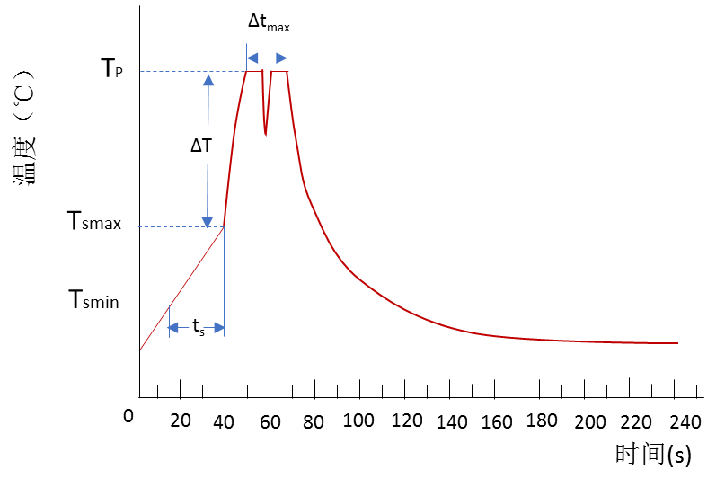Tab：Recommended specification of wave soldering

|  |  |
| --- | --- |
| Soldering parameters | Tantalum capacitance |
| Minimum preheating temperatureTsmin | 70℃ |
| Maximum preheating temperature Tsmax | 130℃ |
| Duration from Tsmin to Tsmax ts | 40s-60s |
| Difference between Tsmax and peak temperatureTP ΔT | 80℃～150℃ |
| Peak temperature TP | 235℃～260℃ |
| Soldering time Δtmax | Contact time per peak 5s，  Total not exceeding 10s |
| Cooling rate | 2℃/s-5℃/s  Fig.17 Recommended Soldering Curve For Wave Soldering |



■ **Struction And Introduction of Characteristic of PYT**

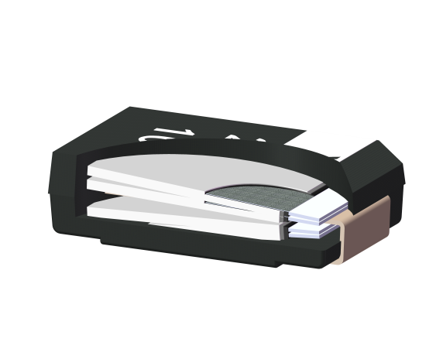

Encapsulated

Silver layer

Organic polymer

Lead wire of anode

Aluminum foil

Fig.18 PYT Series’s Struture

Conductive polymer electrolyte chip aluminum electrolytic capacitors are made of aluminum foil as capacitor matrix, conductive polymer layer as cathode electrolyte.It is made of multilayer aluminum foil stacking welding and epoxy resin encapsulation. PY-Cap aluminium electrolytic capacitor has ultra-low ESR and excellent temperature performance due to its excellent conductivity, good adhesion with dielectric layer and multi-layer parallel structure.

104

103

102

101

Conductive Polymer

TCNQ

（Organic Semiconductor）

Manganese dioxide

（MnO2）

Electorlyte

Conductance（S・m-1）



Fig.19 Schematic Diagram of Conductivity of Cathode Materials for Typical Capacitors

■ **PYT Series’s Tape Size And Reel Size**

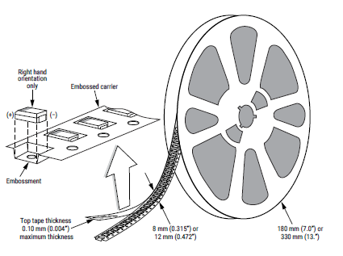

Top tape thickness

0.08mm(0.003”)

maximum thickness

180mm(7.0”)

12mm（0.472”）

Top tape thickness 0.08mm(0.003”)

maximum thickness

Top tape thickness 0.08mm(0.003”)

maximum thickness

Fig.20 Drawing of PY-Cap Reel And Packing Tape

■ **PYT Series Performance And Characteristics**

|  |  |  |  |  |  |
| --- | --- | --- | --- | --- | --- |
| **Item** | | **Performance** | | | **Test condition** |
| Operating temperature | | -55℃　～　105℃ | | | ― |
| Rated voltage | | 2V ～ 50V | | |  |
| Surge voltage | | 1.15UR | | | Temperature：105℃  Times： 1000 |
| Capacitance | | 3.3μF　～　470μF | | | Test frequency：100Hz  Test voltage：0.5Vrms DC |
| Capacitance tolerance | | ±10％、±20％ | | | Test frequency：100Hz  Test voltage：0.5Vrms DC |
| Tangent of loss angle（tanδ） | | Refer to standard ratings | | | Test frequency：100Hz  Test voltage：0.5Vrms DC |
| Leakage current | | Refer to standard ratings | | | Five minutes after rated voltage charging |
| Equivalent series resistance（ESR） | | Refer to standard ratings | | | Test frequency：100KHz  （Partial specification coding 300KHz～500KHz） |
| Ripple current | | Refer to standard ratings | | |  |
|  | | ΔC/C | tanδ | LC |  |
| Surge voltage test | | Lower than ±20% of the initial specification | Lower than initial specification | Lower than initial specification |  |
| Characterinstic of temperature | -55℃ | Lower than ±20% of the initial specification | Lower than 1.5 times the initial specification | - |  |
| +105℃ | Lower than ±20% of the initial specification | Lower than 1.5 times the initial specification | Lower than 12.5 times the initial specification |
| Endurance | | Lower than ±20% of the initial specification | Lower than 1.5 times the initial specification | Lower than initial specification | Temperature：105℃  Voltage：Rated voltage  Time：1000hours |
| Steadydamp-heat | | +70%,-20%(2V~2.5V)  +60%,-20%(4V~50V) | Lower than 2 times the initial specification | Lower than initial specification (2V~6.3V)  ower than 3 times the initial specification (8V~50V) | Temperature：40℃  Humidity： 95%RH  Time：500hours |

**■ PYT series voltage and capacitance range**

|  |  |  |  |  |  |  |  |  |  |  |  |  |  |
| --- | --- | --- | --- | --- | --- | --- | --- | --- | --- | --- | --- | --- | --- |
| UR（V）  CAP（μF） | 2 | 2.5 | 4 | 6.3 | 8 | 10 | 12.5 | 16 | 20 | 25 | 30 | 35 | 50 |
| 3.3 |  |  |  |  |  |  |  |  |  |  |  |  | L |
| 4.7 |  |  |  |  |  |  |  |  |  |  | L | L | L |
| 6.8 |  |  |  |  |  |  |  |  |  |  | L | L | D |
| 8.2 |  |  |  |  |  |  |  |  |  |  | L | L |  |
| 10 |  |  |  |  |  |  |  |  |  | L | L | L |  |
| 15 |  |  |  |  |  |  |  |  | L | L | D | D |  |
| 22 |  |  |  |  |  |  |  | L | L | D |  |  |  |
| 33 |  |  |  |  |  |  | L | L | L |  |  |  |  |
| 47 |  |  |  | L | L | L | L | L | D |  |  |  |  |
| 68 |  |  |  | L | L | L | L | D |  |  |  |  |  |
| 82 |  |  | L | L | L | L | D |  |  |  |  |  |  |
| 100 |  |  | L | L | L | L/D | D |  |  |  |  |  |  |
| 150 | L | L | L | L/D | D |  |  |  |  |  |  |  |  |
| 180 | L | L | L | D |  |  |  |  |  |  |  |  |  |
| 220 | L | L | L/D | D/E |  |  |  |  |  |  |  |  |  |
| 330 | L/D | L/D | D |  |  |  |  |  |  |  |  |  |  |
| 470 | L/D | L/D |  |  |  |  |  |  |  |  |  |  |  |

■ **Coding Rules And Ordering Method of PYT Series Specifications**



（When ordering, please refer to the above naming rules and code specifications, and specify the quantity.）

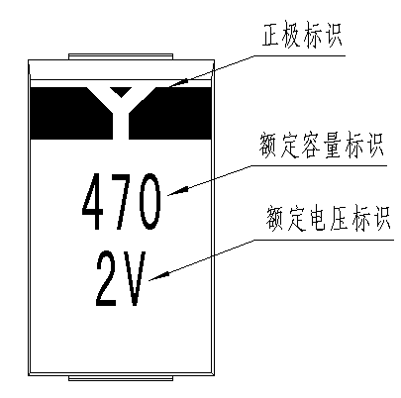■ **PYT Series Logo Printing Style**

【L、D、E　Case】

Example：2V470uF

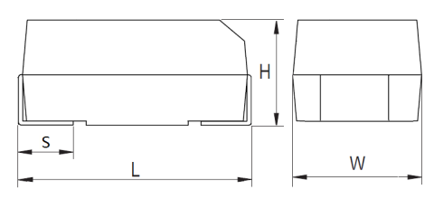■ **PYT Series case and size**

（The patch corresponding to the edge of the factory sign in the product sign is positive pole.）

|  |  |  |  |  |
| --- | --- | --- | --- | --- |
| Case | dimensions unit:mm | | | |
| L | W | H | S |
| L | 7.3±0.3 | 4.3±0.3 | 1.9±0.3 | 1.35±0.3 |
| D | 7.3±0.3 | 4.3±0.3 | 2.8±0.3 | 1.35±0.3 |
| E | 7.3±0.3 | 4.3±0.3 | 4.1±0.3 | 1.35±0.3 |

* **Specification of** **PYT Series**

|  |  |  |  |  |  |  |  |  |
| --- | --- | --- | --- | --- | --- | --- | --- | --- |
| Rated voltage  （V） | Capacitance  （μF） | Case | Specification code | Rated temperature  （℃） | LC  （μA，+25℃） | tanδ  （+25℃  ,100Hz） | ESR  （mΩ，+25℃  ，100KHz） | Max ripple current  （mArms）（45℃,100KHz） |
| 2 | 150 | L | PYTL002M157E025 | 105 | 18.0 | 6 | 25 | 3500 |
| 150 | L | PYTL002M157E012 | 105 | 18.0 | 6 | 12 | 4200 |
| 180 | L | PYTL002M187E020 | 105 | 21.6 | 6 | 20 | 3800 |
| 180 | L | PYTL002M187E012 | 105 | 21.6 | 6 | 12 | 4200 |
| 220 | L | PYTL002M227E020 | 105 | 26.4 | 6 | 20 | 3800 |
| 220 | L | PYTL002M227E012 | 105 | 26.4 | 6 | 12 | 4200 |
| 330 | L | PYTL002M337E020 | 105 | 39.6 | 6 | 20 | 3800 |
| 330 | L | PYTL002M337E015 | 105 | 39.6 | 6 | 15 | 4000 |
| 330 | L | PYTL002M337E009 | 105 | 39.6 | 6 | 9 | 4300 |
| 330 | D | PYTD002M337E020 | 105 | 39.6 | 6 | 20 | 3800 |
| 330 | D | PYTD002M337E015 | 105 | 39.6 | 6 | 15 | 4000 |
| 330 | D | PYTD002M337E009 | 105 | 39.6 | 6 | 9 | 4300 |
| 470 | L | PYTL002M477E020 | 105 | 56.4 | 6 | 20 | 3800 |
| 470 | L | PYTL002M477E015 | 105 | 56.4 | 6 | 15 | 4000 |
| 470 | L | PYTL002M477E009 | 105 | 56.4 | 6 | 9 | 4300 |
| 470 | D | PYTD002M477E020 | 105 | 56.4 | 6 | 20 | 3800 |
| 470 | D | PYTD002M477E015 | 105 | 56.4 | 6 | 15 | 4000 |
| 470 | D | PYTD002M477E009 | 105 | 56.4 | 6 | 9 | 4300 |
| 2.5 | 150 | L | PYTL2R5M157E025 | 105 | 22.5 | 6 | 25 | 3500 |
| 150 | L | PYTL2R5M157E012 | 105 | 22.5 | 6 | 12 | 4200 |
| 180 | L | PYTL2R5M187E020 | 105 | 27 | 6 | 20 | 3800 |
| 180 | L | PYTL2R5M187E012 | 105 | 27 | 6 | 12 | 4200 |
| 220 | L | PYTL2R5M227E020 | 105 | 33 | 6 | 20 | 3800 |
| 220 | L | PYTL2R5M227E012 | 105 | 33 | 6 | 12 | 4200 |
| 330 | L | PYTL2R5M337E020 | 105 | 49.5 | 6 | 20 | 3800 |
| 330 | L | PYTL2R5M337E015 | 105 | 49.5 | 6 | 15 | 4000 |
| 330 | L | PYTL2R5M337E009 | 105 | 49.5 | 6 | 9 | 4300 |
| 330 | D | PYTD2R5M337E020 | 105 | 49.5 | 6 | 20 | 3800 |
| 330 | D | PYTD2R5M337E015 | 105 | 49.5 | 6 | 15 | 4000 |
| 330 | D | PYTD2R5M337E009 | 105 | 49.5 | 6 | 9 | 4300 |
| 470 | L | PYTL2R5M477E020 | 105 | 70.5 | 6 | 20 | 3800 |
| 470 | L | PYTL2R5M477E015 | 105 | 70.5 | 6 | 15 | 4000 |
| 470 | L | PYTL2R5M477E009 | 105 | 70.5 | 6 | 9 | 4300 |
| 470 | D | PYTD2R5M477E020 | 105 | 70.5 | 6 | 20 | 3800 |
| 470 | D | PYTD2R5M477E015 | 105 | 70.5 | 6 | 15 | 4000 |
| 470 | D | PYTD2R5M477E009 | 105 | 70.5 | 6 | 9 | 4300 |
| 4 | 82 | L | PYTL004M826E030 | 105 | 19.7 | 6 | 30 | 3200 |
| 82 | L | PYTL004M826E015 | 105 | 19.7 | 6 | 15 | 4000 |
| 100 | L | PYTL004M107E030 | 105 | 24 | 6 | 30 | 3200 |
| 100 | L | PYTL004M107E015 | 105 | 24 | 6 | 15 | 4000 |

* **Specification of** **PYT Series** **(Continued)**

|  |  |  |  |  |  |  |  |  |
| --- | --- | --- | --- | --- | --- | --- | --- | --- |
| Rated voltage  （V） | Capacitance  （μF） | Case | Specification code | Rated temperature  （℃） | LC  （μA，+25℃） | tanδ  （+25℃  ,100Hz） | ESR  （mΩ，+25℃  ，100KHz） | Max ripple current  （mArms）（45℃,100KHz） |
| 4 | 150 | L | PYTL004M157E020 | 105 | 36 | 6 | 20 | 3800 |
| 150 | L | PYTL004M157E015 | 105 | 36 | 6 | 15 | 4000 |
| 150 | L | PYTL004M157E009 | 105 | 36 | 6 | 9 | 4300 |
| 180 | L | PYTL004M187E020 | 105 | 43.2 | 6 | 20 | 3800 |
| 220 | L | PYTL004M227E020 | 105 | 52.8 | 6 | 20 | 3800 |
| 220 | L | PYTL004M227E015 | 105 | 52.8 | 6 | 15 | 4000 |
| 220 | L | PYTL004M227E009 | 105 | 52.8 | 6 | 9 | 4300 |
| 220 | D | PYTD004M227E020 | 105 | 52.8 | 6 | 20 | 3800 |
| 220 | D | PYTD004M227E015 | 105 | 52.8 | 6 | 15 | 4000 |
| 220 | D | PYTD004M227E009 | 105 | 52.8 | 6 | 9 | 4300 |
| 330 | D | PYTD004M337E020 | 105 | 79.2 | 6 | 20 | 3800 |
| 330 | D | PYTD004M337E015 | 105 | 79.2 | 6 | 15 | 4000 |
| 330 | D | PYTD004M337E009 | 105 | 79.2 | 6 | 9 | 4300 |
| 6.3 | 47 | L | PYTL6R3M476E035 | 105 | 11.8 | 6 | 35 | 3000 |
| 47 | L | PYTL6R3M476E020 | 105 | 11.8 | 6 | 20 | 3800 |
| 56 | L | PYTL6R3M566E030 | 105 | 14.1 | 6 | 30 | 3200 |
| 68 | L | PYTL6R3M686E030 | 105 | 17.1 | 6 | 30 | 3200 |
| 68 | L | PYTL6R3M686E020 | 105 | 17.1 | 6 | 20 | 3800 |
| 82 | L | PYTL6R3M826E030 | 105 | 20.7 | 6 | 30 | 3200 |
| 100 | L | PYTL6R3M107E030 | 105 | 25 | 6 | 30 | 3200 |
| 100 | L | PYTL6R3M107E015 | 105 | 25 | 6 | 15 | 4000 |
| 150 | L | PYTL6R3M157E025 | 105 | 37.8 | 6 | 25 | 3500 |
| 150 | L | PYTL6R3M157E015 | 105 | 37.8 | 6 | 15 | 4000 |
| 150 | D | PYTD6R3M157E025 | 105 | 37.8 | 6 | 25 | 3500 |
| 150 | D | PYTD6R3M157E015 | 105 | 37.8 | 6 | 15 | 4000 |
| 180 | D | PYTD6R3M187E020 | 105 | 45.4 | 6 | 20 | 3800 |
| 220 | D | PYTD6R3M227E020 | 105 | 55.4 | 6 | 20 | 3800 |
| 220 | D | PYTD6R3M227E015 | 105 | 55.4 | 6 | 15 | 4000 |
| 220 | D | PYTD6R3M227E012 | 105 | 55.4 | 6 | 12 | 4200 |
| 220 | E | PYTE6R3M227E020 | 105 | 55.4 | 6 | 20 | 3800 |
| 220 | E | PYTE6R3M227E015 | 105 | 55.4 | 6 | 15 | 4000 |
| 220 | E | PYTE6R3M227E012 | 105 | 55.4 | 6 | 12 | 4200 |
| 8 | 47 | L | PYTL008M476E030 | 105 | 15 | 6 | 30 | 3200 |
| 47 | L | PYTL008M476E020 | 105 | 15 | 6 | 20 | 3800 |
| 56 | L | PYTL008M566E025 | 105 | 17.9 | 6 | 25 | 3500 |
| 68 | L | PYTL008M686E025 | 105 | 21.8 | 6 | 25 | 3500 |
| 68 | L | PYTL008M686E020 | 105 | 21.8 | 6 | 20 | 3800 |
| 82 | L | PYTL008M826E025 | 105 | 26.2 | 6 | 25 | 3500 |
| 100 | L | PYTL008M107E020 | 105 | 32 | 6 | 20 | 3800 |
| 100 | L | PYTL008M107E015 | 105 | 32 | 6 | 15 | 4000 |

* **Specification of** **PYT Series** **(Continued)**

|  |  |  |  |  |  |  |  |  |
| --- | --- | --- | --- | --- | --- | --- | --- | --- |
| Rated voltage  （V） | Capacitance  （μF） | Case | Specification code | Rated temperature  （℃） | LC  （μA，+25℃） | tanδ  （+25℃  ,100Hz） | ESR  （mΩ，+25℃  ，100KHz） | Max ripple current  （mArms）（45℃,100KHz） |
| 8 | 150 | D | PYTD008M157E020 | 105 | 48 | 6 | 20 | 3800 |
| 150 | D | PYTD008M157E015 | 105 | 48 | 6 | 15 | 4000 |
| 10 | 47 | L | PYTL010M476E035 | 105 | 18.8 | 6 | 35 | 3000 |
| 47 | L | PYTL010M476E020 | 105 | 18.8 | 6 | 20 | 3800 |
| 56 | L | PYTL010M566E030 | 105 | 22.4 | 6 | 30 | 3200 |
| 68 | L | PYTL010M686E030 | 105 | 27.2 | 6 | 30 | 3200 |
| 68 | L | PYTL010M686E020 | 105 | 27.2 | 6 | 20 | 3800 |
| 82 | L | PYTL010M826E030 | 105 | 32.8 | 6 | 30 | 3200 |
| 100 | L | PYTL010M107E025 | 105 | 40 | 6 | 25 | 3500 |
| 100 | L | PYTL010M107E015 | 105 | 40 | 6 | 15 | 4000 |
| 100 | D | PYTD010M107E025 | 105 | 40 | 6 | 25 | 3500 |
| 100 | D | PYTD010M107E015 | 105 | 40 | 6 | 15 | 4000 |
| 12.5 | 33 | L | PYTL12RM336E035 | 105 | 16.5 | 6 | 35 | 3000 |
| 33 | L | PYTL12RM336E025 | 105 | 16.5 | 6 | 25 | 3500 |
| 47 | L | PYTL12RM476E035 | 105 | 23.5 | 6 | 35 | 3000 |
| 47 | L | PYTL12RM476E025 | 105 | 23.5 | 6 | 25 | 3500 |
| 56 | L | PYTL12RM566E030 | 105 | 28 | 6 | 30 | 3200 |
| 68 | L | PYTL12RM686E030 | 105 | 34 | 6 | 30 | 3200 |
| 68 | L | PYTL12RM686E025 | 105 | 34 | 6 | 25 | 3500 |
| 82 | D | PYTD12RM826E025 | 105 | 41 | 6 | 25 | 3500 |
| 100 | D | PYTD12RM107E025 | 105 | 50 | 6 | 25 | 3500 |
| 100 | D | PYTD12RM107E020 | 105 | 50 | 6 | 20 | 3800 |
| 16 | 22 | L | PYTL016M226E040 | 105 | 14.1 | 6 | 40 | 2800 |
| 22 | L | PYTL016M226E025 | 105 | 14.1 | 6 | 25 | 3500 |
| 33 | L | PYTL016M336E040 | 105 | 21.1 | 6 | 40 | 2800 |
| 33 | L | PYTL016M336E025 | 105 | 21.1 | 6 | 25 | 3500 |
| 47 | L | PYTL016M476E040 | 105 | 30.1 | 6 | 40 | 2800 |
| 47 | L | PYTL016M476E025 | 105 | 30.1 | 6 | 25 | 3500 |
| 68 | D | PYTD016M686E030 | 105 | 43.5 | 6 | 30 | 3200 |
| 68 | D | PYTD016M686E020 | 105 | 43.5 | 6 | 20 | 3800 |
| 20 | 15 | L | PYTL020M156E040 | 105 | 12 | 6 | 40 | 2800 |
| 15 | L | PYTL020M156E025 | 105 | 12 | 6 | 25 | 3500 |
| 22 | L | PYTL020M226E035 | 105 | 17.6 | 6 | 35 | 3000 |
| 22 | L | PYTL020M226E025 | 105 | 17.6 | 6 | 25 | 3500 |
| 33 | L | PYTL020M336E035 | 105 | 26.4 | 6 | 35 | 3000 |
| 33 | L | PYTL020M336E020 | 105 | 26.4 | 6 | 20 | 3800 |
| 47 | D | PYTD020M476E030 | 105 | 37.6 | 6 | 30 | 3200 |
| 47 | D | PYTD020M476E020 | 105 | 37.6 | 6 | 20 | 3800 |

* **Specification of** **PYT Series** **(Continued)**

|  |  |  |  |  |  |  |  |  |
| --- | --- | --- | --- | --- | --- | --- | --- | --- |
| Rated voltage  （V） | Capacitance  （μF） | Case | Specification code | Rated temperature  （℃） | LC  （μA，+25℃） | tanδ  （+25℃  ,100Hz） | ESR  （mΩ，+25℃  ，100KHz） | Max ripple current  （mArms）（105℃,100KHz） |
| 25 | 10 | L | PYTL025M106E035 | 105 | 10 | 6 | 35 | 3000 |
| 10 | L | PYTL025M106E025 | 105 | 10 | 6 | 25 | 3500 |
| 15 | L | PYTL025M156E035 | 105 | 15 | 6 | 35 | 3000 |
| 15 | L | PYTL025M156E025 | 105 | 15 | 6 | 25 | 3500 |
| 22 | D | PYTD025M226E030 | 105 | 22 | 6 | 30 | 3200 |
| 22 | D | PYTD025M226E020 | 105 | 22 | 6 | 20 | 3800 |
| 30 | 4.7 | L | PYTL030M475E045 | 105 | 5.6 | 6 | 45 | 2600 |
| 4.7 | L | PYTL030M475E030 | 105 | 5.6 | 6 | 30 | 3200 |
| 6.8 | L | PYTL030M685E040 | 105 | 8.2 | 6 | 40 | 2800 |
| 6.8 | L | PYTL030M685E030 | 105 | 8.2 | 6 | 30 | 3200 |
| 8.2 | L | PYTL030M825E040 | 105 | 9.8 | 6 | 40 | 2800 |
| 10 | L | PYTL030M106E040 | 105 | 12 | 6 | 40 | 2800 |
| 10 | L | PYTL030M106E025 | 105 | 12 | 6 | 25 | 3500 |
| 15 | D | PYTD030M156E040 | 105 | 18 | 6 | 40 | 2800 |
| 15 | D | PYTD030M156E025 | 105 | 18 | 6 | 25 | 3500 |
| 35 | 4.7 | L | PYTL035M475E045 | 105 | 6.5 | 6 | 45 | 2600 |
| 4.7 | L | PYTL035M475E030 | 105 | 6.5 | 6 | 30 | 3200 |
| 6.8 | L | PYTL035M685E040 | 105 | 9.5 | 6 | 40 | 2800 |
| 6.8 | L | PYTL035M685E030 | 105 | 9.5 | 6 | 30 | 3200 |
| 8.2 | L | PYTL035M825E040 | 105 | 11.4 | 6 | 40 | 2800 |
| 10 | L | PYTL035M106E040 | 105 | 14 | 6 | 40 | 2800 |
| 10 | L | PYTL035M106E025 | 105 | 14 | 6 | 25 | 3500 |
| 15 | D | PYTD035M156E040 | 105 | 21 | 6 | 40 | 2800 |
| 15 | D | PYTD035M156E025 | 105 | 21 | 6 | 25 | 3500 |
| 50 | 3.3 | L | PYTL050M335E040 | 105 | 6.6 | 6 | 40 | 2800 |
| 3.3 | L | PYTL050M335E025 | 105 | 6.6 | 6 | 25 | 3500 |
| 4.7 | L | PYTL050M475E040 | 105 | 9.4 | 6 | 40 | 2800 |
| 4.7 | L | PYTL050M475E025 | 105 | 9.4 | 6 | 25 | 3500 |
| 6.8 | D | PYTD050M685E040 | 105 | 13.6 | 6 | 40 | 2800 |
| 6.8 | D | PYTD050M685E025 | 105 | 13.6 | 6 | 25 | 3500 |

*Rated ripple current（100kHz/+45℃）

Rated ripple current and temperature coefficient table

|  |  |  |
| --- | --- | --- |
| Rated ripple current and temperature coefficient | | |
| ≤45℃ | 45℃＜T≤85℃ | 85℃＜T≤105℃ |
| 1.00 | 0.83 | 0.53 |

■ **PYT Series About Soldering**

（1）Recommended pad sizes

Tab： Sizes of pad

|  |  |  |  |
| --- | --- | --- | --- |
| Case | X  （mm） | Y  （mm） | Z  （mm） |
| L、D、E | 2.4 | 2.9 | 3.7 |

Z

X

Y

X

（2）Recommended reflow temperature

When using soldering iron, it should be used below 30W, the tip temperature of soldering iron should be less than 350℃, and the time should be less than 3 seconds. （Nevertheless, do not touch the capacitor body with a soldering iron head or exert a strong force on it.）

When using reflow soldering, refer to the recommended soldering curve as follows.

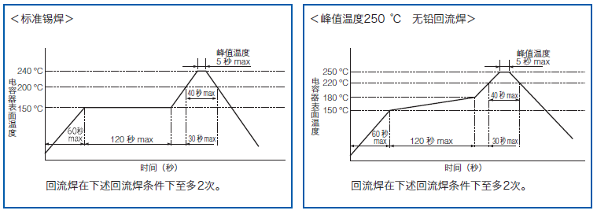

Fig.21 Recommended Reflow Soldering Curve of PYT Series

**HQ（High Q） & HV（High voltage） Series**



■ **Structure of HQ Series & HV Series**

Product Structure Diagram

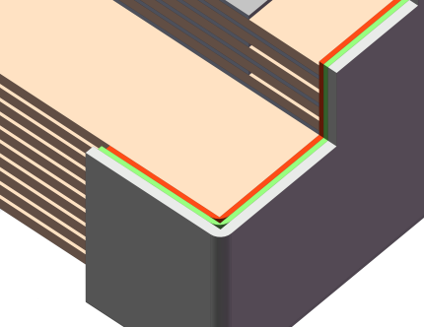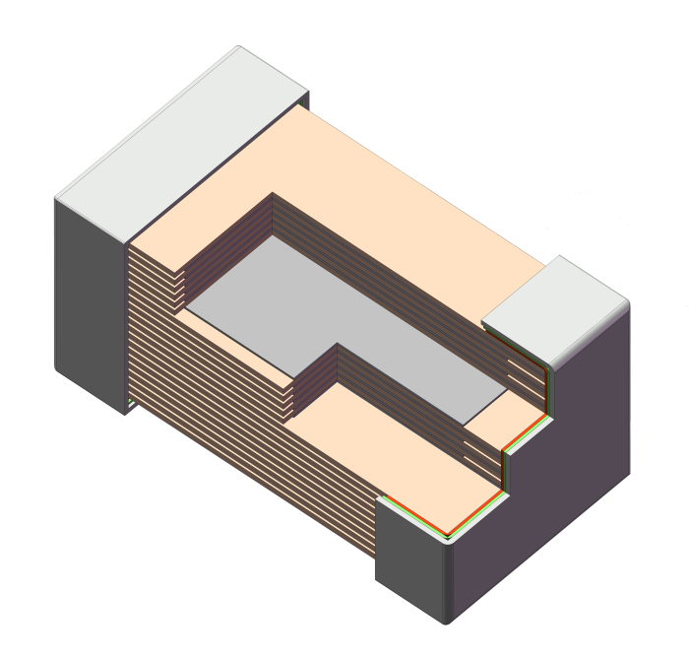

Ceramic dielectric

Internal electrode：Ag/Pd

End electrode (inner)：Ag

End electrode (middle)：Ni

End electrode (outside)：Sn&Pb

Enlarge

Fig.22 Structure Digram of HQ & HV Serirs MLCC

HQ-type products adopt multi-stage suspension special structure design, use special high-Q ceramic powder with excellent performance parameters as ceramic dielectric material, and use precious metal silver-palladium material as internal electrode and silver/nickel/tin-lead as external end electrode，Therefore, HQ-type products have high Q specification (Q≥10000, working frequency up to 3GHz), low ESR and high reliability (life up to 1000h).H HV-type products are designed with multi-stage suspension and co-directional special structures, using high-pressure ceramic powder with excellent dielectric strength as ceramic dielectric material, and using noble metal Ag-Pd material as internal electrode and silver/nickel/tin-lead as external terminal electrode. Therefore, the rated voltage of HV-type products can reach 12 KV and have high reliability, and the service life can reach 1000 hours.

■ **HQ series & HV series Tape & Reel Packaging Information**

T：Bulk packaging：Vacuum packaging of antistatic bags，package quantity：50pcs/package，200pcs/package，500pcs/package；

F：Tape packing：Coil paper tape packaging，package quantity：4000pcs/7〞disc（2012）；

E：Tape packing：Wrapping and packaging of coil clinker，package quantity：4000pcs/7〞disc（2828）；

500 pcs/7〞disc（5764）；

Note：Packaging defaults to T without special instructions.

■ **Table of HQ Series Performance And Characteristic**

|  |  |  |  |  |  |  |  |  |
| --- | --- | --- | --- | --- | --- | --- | --- | --- |
| **Item** | **Performance** | | | | | | | **Test condition** |
| Operating temperature | -55℃～125℃ | | | | | | | ― |
| Capacitance | 0.1pF～5100pF | | | | | | | CR≤1000pF，f=(1±0.2)MHz CR>1000pF，f=(1±0.2)KHz |
| Quality factor | Q≥10000 | | | | | | | Execution according to Q/MM188-2013 |
| Voltage | 50V～3.6KV | | | | | | | UR＜250V：2.5UR  250V≤UR＜500V：1.5UR+100V  500V≤UR＜1KV：1.5UR  1KV＜UR＜1.2KV：1.25UR  UR≥1.2KV：1.2UR |
| Insulation resistance | CR≤0.01μF：IR≥105MΩ  CR＞0.01μF：IR≥1000/CRMΩ·uF | | | | | | | UR≤500V，test voltage is UR；  UR>500V，test voltage is 500V。 |
| Capacitance tolerance | B | C | D | F | G | J | K | ― |
| ±0.1pF | ±0.1pF | ±0.1pF | ±1% | ±2% | ±5% | ±10% |
| Temperature characteristic | 0±30ppm/℃ | | | | | | | Execution according to Q/MM188-2013 |
| Life at high temperature | Conform with initial specification requirements | | | | | | | Temperature：125℃  Voltage：UR＜500V: 2UR  500≤UR≤1000V: 1.5UR  UR＞1000V: 1.2UR  Time：1000h |

■ **Coding Rules And Ordering Method of HQ Series Model Specifications**

CC41HQ 2828 C0G 1KV 101 J W X B

Packaging method T/B

Logo code

Ends form form

Code of capacitance tolerance B/C/D/F/G/J/K/M

Capacitance code 101=100pF

Rated voltage

Tempreture characteristic C0G

Size code

Model CC41HQ

CC48\CT48\CC41HQ

■ **Form of HQ Sriese End**

|  |  |  |  |  |  |  |  |
| --- | --- | --- | --- | --- | --- | --- | --- |
| Name of end | End code | | End Type Diagram | Size code | End electrode /Size of lea wire | | |
| Magnetic | Nonmagnetic | LL(mm) | WL(mm) | TL(mm) |
| Microstrip | MS | MN |  | 2828 | 6.35min | 2.36±0.13 | 0.2±0.025 |
| 5764 | 12.7 min | 6.10±0.13 | 0.2±0.025 |
| 9797 | 19.05 min | 8.89±0.25 | 0.2±0.025 |
| Axial band | AR | AN | 5764 | 12.7 min | 6.10±0.13 | 0.2±0.025 |
| 9797 | 19.05min | 8.89±0.25 | 0.2±0.025 |
| Radial belt | RR | FN | 2828 | 6.35 min | 2.60±0.05 | 0.1±0.05 |
| 5764 | 10min | 3.00±0.13 | 0.3±0.025 |
| 9797 | 10min | 3.00±0.13 | 0.3±0.05 |
| Axial line | AW | BN | 5764 | 25min | Tin-plated copper lead wire  diameter of lead wire：  0.80±0.10 | |
| 9797 | 25min |
| Radial line | RW | RN | 5764 | 20min |
| 9797 | 20min |
| Chip | W | p | See Fig.23 | See the table of capacitor size | | | |

■Outline Size

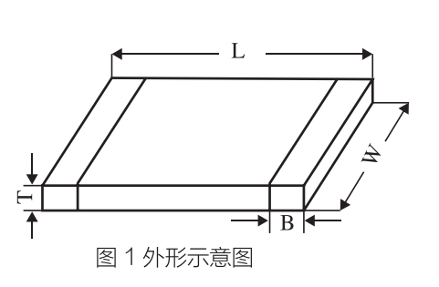

Fig.23 HQ Series Outline Drawing

|  |  |  |  |  |  |  |
| --- | --- | --- | --- | --- | --- | --- |
| Size code  Metric System (British System) | 1414  （0505） | 1608  （0603） | 2012  （0805） | 2828  （1111） | 5764  （2225） | 9797  （3838） |
| L | 1.40±0.40 | 1.60±0.30 | 2.03±0.30 | 2.80±0.50 | 5.70±0.50 | 9.70±0.50 |
| W | 1.40±0.40 | 0.80±0.20 | 1.27±0.20 | 2.80±0.50 | 6.50±0.50 | 9.70±0.50 |
| Tmax | 1.40 | 1.40 | 1.40 | 3.00 | 4.0 | 4.0 |
| B | 0.50±0.25 | 0.40±0.25 | 0.50±0.30 | 0.50±0.25 | 0.90±0.60 | 1.00±0.50 |

Note：All the above length units are mm.Thickness has special requirements, please consult our company.

■ **Table of Voltage And Capacitance of Type CC41HQ**

|  |  |  |  |  |  |  |  |  |  |  |  |  |  |  |
| --- | --- | --- | --- | --- | --- | --- | --- | --- | --- | --- | --- | --- | --- | --- |
| Outline size  Metric System  (British System) | 1414  （0505） | | | | 1608  （0603） | | | | | 2012  （0805） | | | | |
| UR(V)  Rated capaciy | 50 | 150 | 200 | 250 | 50 | 100 | 150 | 200 | 250 | 50 | 100 | 150 | 200 | 250 |
| 0R1-1R0 |  |  |  |  |  |  |  |  |  |  |  |  |  |  |
| 1R0-1R9 |  |  |  |  |  |  |  |  |  |  |  |  |  |  |
| 2R2 |  |  |  |  |  |  |  |  |  |  |  |  |  |  |
| 2R7 |  |  |  |  |  |  |  |  |  |  |  |  |  |  |
| 3R3 |  |  |  |  |  |  |  |  |  |  |  |  |  |  |
| 4R7 |  |  |  |  |  |  |  |  |  |  |  |  |  |  |
| 5R6 |  |  |  |  |  |  |  |  |  |  |  |  |  |  |
| 6R8 |  |  |  |  |  |  |  |  |  |  |  |  |  |  |
| 7R5 |  |  |  |  |  |  |  |  |  |  |  |  |  |  |
| 8R2 |  |  |  |  |  |  |  |  |  |  |  |  |  |  |
| 9R1 |  |  |  |  |  |  |  |  |  |  |  |  |  |  |
| 100 |  |  |  |  |  |  |  |  |  |  |  |  |  |  |
| 150 |  |  |  |  |  |  |  |  |  |  |  |  |  |  |
| 220 |  |  |  |  |  |  |  |  |  |  |  |  |  |  |
| 270 |  |  |  |  |  |  |  |  |  |  |  |  |  |  |
| 330 |  |  |  |  |  |  |  |  |  |  |  |  |  |  |
| 390 |  |  |  |  |  |  |  |  |  |  |  |  |  |  |
| 470 |  |  |  |  |  |  |  |  |  |  |  |  |  |  |
| 560 |  |  |  |  |  |  |  |  |  |  |  |  |  |  |
| 680 |  |  |  |  |  |  |  |  |  |  |  |  |  |  |
| 750 |  |  |  |  |  |  |  |  |  |  |  |  |  |  |
| 820 |  |  |  |  |  |  |  |  |  |  |  |  |  |  |
| 910 |  |  |  |  |  |  |  |  |  |  |  |  |  |  |
| 101 |  |  |  |  |  |  |  |  |  |  |  |  |  |  |
| 151 |  |  |  |  |  |  |  |  |  |  |  |  |  |  |
| 221 |  |  |  |  |  |  |  |  |  |  |  |  |  |  |
| 271 |  |  |  |  |  |  |  |  |  |  |  |  |  |  |
| 331 |  |  |  |  |  |  |  |  |  |  |  |  |  |  |
| 391 |  |  |  |  |  |  |  |  |  |  |  |  |  |  |
| 471 |  |  |  |  |  |  |  |  |  |  |  |  |  |  |
| 561 |  |  |  |  |  |  |  |  |  |  |  |  |  |  |
| 681 |  |  |  |  |  |  |  |  |  |  |  |  |  |  |
| 751 |  |  |  |  |  |  |  |  |  |  |  |  |  |  |
| 821 |  |  |  |  |  |  |  |  |  |  |  |  |  |  |
| 911 |  |  |  |  |  |  |  |  |  |  |  |  |  |  |
| 102 |  |  |  |  |  |  |  |  |  |  |  |  |  |  |

■**Table of Voltage And Capacitance of Type CC41HQ（Continued）**

|  |  |  |  |  |  |  |  |  |  |  |  |  |  |  |  |
| --- | --- | --- | --- | --- | --- | --- | --- | --- | --- | --- | --- | --- | --- | --- | --- |
| Outline size  Metric System  (British System) | 2828  （1111） | | | | | | 5764  （2225） | | | | | 9797  （3838） | | | |
| UR(V)  Rated capacitance | 50 | 150 | 200 | 300 | 500 | 1k | 300 | 500 | 1k | 1.5k | 2.5k | 500 | 1k | 2.5k | 3.6k |
| 0R1-1R0 |  |  |  |  |  |  |  |  |  |  |  |  |  |  |  |
| 1R0-1R9 |  |  |  |  |  |  |  |  |  |  |  |  |  |  |  |
| 2R2 |  |  |  |  |  |  |  |  |  |  |  |  |  |  |  |
| 2R7 |  |  |  |  |  |  |  |  |  |  |  |  |  |  |  |
| 3R3 |  |  |  |  |  |  |  |  |  |  |  |  |  |  |  |
| 4R7 |  |  |  |  |  |  |  |  |  |  |  |  |  |  |  |
| 5R6 |  |  |  |  |  |  |  |  |  |  |  |  |  |  |  |
| 6R8 |  |  |  |  |  |  |  |  |  |  |  |  |  |  |  |
| 7R5 |  |  |  |  |  |  |  |  |  |  |  |  |  |  |  |
| 8R2 |  |  |  |  |  |  |  |  |  |  |  |  |  |  |  |
| 9R1 |  |  |  |  |  |  |  |  |  |  |  |  |  |  |  |
| 100 |  |  |  |  |  |  |  |  |  |  |  |  |  |  |  |
| 150 |  |  |  |  |  |  |  |  |  |  |  |  |  |  |  |
| 220 |  |  |  |  |  |  |  |  |  |  |  |  |  |  |  |
| 270 |  |  |  |  |  |  |  |  |  |  |  |  |  |  |  |
| 330 |  |  |  |  |  |  |  |  |  |  |  |  |  |  |  |
| 390 |  |  |  |  |  |  |  |  |  |  |  |  |  |  |  |
| 470 |  |  |  |  |  |  |  |  |  |  |  |  |  |  |  |
| 560 |  |  |  |  |  |  |  |  |  |  |  |  |  |  |  |
| 680 |  |  |  |  |  |  |  |  |  |  |  |  |  |  |  |
| 750 |  |  |  |  |  |  |  |  |  |  |  |  |  |  |  |
| 820 |  |  |  |  |  |  |  |  |  |  |  |  |  |  |  |
| 101 |  |  |  |  |  |  |  |  |  |  |  |  |  |  |  |
| 151 |  |  |  |  |  |  |  |  |  |  |  |  |  |  |  |
| 221 |  |  |  |  |  |  |  |  |  |  |  |  |  |  |  |
| 271 |  |  |  |  |  |  |  |  |  |  |  |  |  |  |  |
| 331 |  |  |  |  |  |  |  |  |  |  |  |  |  |  |  |
| 391 |  |  |  |  |  |  |  |  |  |  |  |  |  |  |  |
| 471 |  |  |  |  |  |  |  |  |  |  |  |  |  |  |  |
| 561 |  |  |  |  |  |  |  |  |  |  |  |  |  |  |  |
| 681 |  |  |  |  |  |  |  |  |  |  |  |  |  |  |  |
| 751 |  |  |  |  |  |  |  |  |  |  |  |  |  |  |  |
| 821 |  |  |  |  |  |  |  |  |  |  |  |  |  |  |  |
| 102 |  |  |  |  |  |  |  |  |  |  |  |  |  |  |  |
| 112 |  |  |  |  |  |  |  |  |  |  |  |  |  |  |  |
| 132 |  |  |  |  |  |  |  |  |  |  |  |  |  |  |  |
| 152 |  |  |  |  |  |  |  |  |  |  |  |  |  |  |  |
| 162 |  |  |  |  |  |  |  |  |  |  |  |  |  |  |  |
| 202 |  |  |  |  |  |  |  |  |  |  |  |  |  |  |  |
| 222 |  |  |  |  |  |  |  |  |  |  |  |  |  |  |  |
| 242 |  |  |  |  |  |  |  |  |  |  |  |  |  |  |  |
| 272 |  |  |  |  |  |  |  |  |  |  |  |  |  |  |  |
| 332 |  |  |  |  |  |  |  |  |  |  |  |  |  |  |  |
| 362 |  |  |  |  |  |  |  |  |  |  |  |  |  |  |  |
| 472 |  |  |  |  |  |  |  |  |  |  |  |  |  |  |  |
| 512 |  |  |  |  |  |  |  |  |  |  |  |  |  |  |  |

■ **Table of Performance And Characteristic of HV（High Voltage）Series**

|  |  |  |  |  |  |  |  |
| --- | --- | --- | --- | --- | --- | --- | --- |
| **Item** | **Performance** | | | | | | **Test condition** |
| Operating temperature | -55℃～125℃ | | | | | | ― |
| Range of rated capacitance | C0G | 10pF～270000pF | | | | | C0G：CR≤1000pF，f=(1±0.2)MHz  CR>1000pF，f=(1±0.2)KHz  X7R：CR≤100pF，f=(1±0.2)MHz  100pF＜CR≤10μF,f=(1±0.2)KHz  CR＞10μF，f=(100±20)Hz |
| X7R | 10pF～1000000pF | | | | |
| Tagent of loss angels | C0G | CR＜5pF：tgδ with no requirement  5pF≤CR≤50pF：tgδ≤1.5×(150/CR+7)×10-4  CR＞50pF：tgδ≤15×10-4  Note：The CR unit in the upper form is pF. | | | | | The same as above. |
| X7R | tgδ≤250×10-4 | | | | |
| Range of rated voltage | 250V～12KV | | | | | | UR＜500V：1.5UR+100V  500V≤UR＜1KV：1.3UR+100V  UR≥1KV：1.2UR |
| Insulation resistance | C0G | CR≤0.01μF：IR≥104MΩ  CR＞0.01μF：IR≥ $\frac{100}{C_{R}}$ MΩ·uF  Note：The CR unit in the upper form is pF. | | | | | When UR≤500V，test voltage is UR；  When UR>500V，test voltage is 500V. |
| X7R | CR＜0.025μF： IR≥4000MΩ  CR≥0.025μF：IR≥ $\frac{100}{C_{R}}$ MΩ·uF  Note：The CR unit in the upper form is pF. | | | | |
| Tolerance of capacitance | B | | C | | D | F | - |
| ±0.1pF | | ±0.1pF | | ±0.1pF | ±1% |
| G | | J | | K | M |
| ±2% | | ±5% | | ±10% | ±20% |
| Characteristic of temperature | C0G | | | 0±30ppm/℃ | | | - |
| X7R | | | -15%～+15% | | |
| Life at high temperature | Conform to initial specification requirements | | | | | | Temperature：125℃  Voltage：UR＜500V: 2UR  500≤UR≤1000V: 1.5UR  UR＞1000V: 1.2UR  Time：1000h |

■**HV（High voltage）Coding Rules of Model Specifications And Ordering Methods**

When ordering, please refer to the following naming rules and specifications, code specifications, and specify the quantity.

CC48 1210 C0G 1KV 101 K T

Capacitance code

101=100pF

Code of capacitance tolerance

Rated voltage

Tempreture characteristic

CC0G/X7R

Size code

Model

CC48/CT48

Package form T/F/E

■**Outline Size of HV（High Voltage）**



Fig.24 Outline Diagram of HV Series

|  |  |  |  |  |  |  |  |  |  |  |  |
| --- | --- | --- | --- | --- | --- | --- | --- | --- | --- | --- | --- |
| Size code  Metric System  (British System) | 1608  (0603) | 2012  (0805) | 3216  (1206) | 3225  (1210) | 4520  (1808) | 4532  (1812) | 5750  (2220) | 5764  (2225) | 92102  （3640） | 140127  （5550） | 203152（8060） |
| L | 1.60±0.30 | 2.03±0.30 | 3.20±0.30 | 3.20±0.30 | 4.50±0.40 | 4.50±0.40 | 5.70±0.50 | 5.70±0.50 | 9.20±0.50 | 14.0±1.00 | 20.31±1.50 |
| W | 0.80±0.20 | 1.27±0.20 | 1.6±0.20 | 2.50±0.30 | 2.03±0.30 | 3.20±0.30 | 5.00±0.50 | 6.50±0.50 | 10.2±0.50 | 12.7±1.00 | 15.20±1.50 |
| Tmax | 1.00 | 1.40 | 1.80 | 2.70 | 2.30 | 3.50 | 4.00 | 4.00 | 4.00 | 4.00 | 4.00 |
| B | 0.40±0.25 | 0.50±0.30 | 0.50±0.35 | 0.60±0.40 | 0.75±0.39 | 0.90±0.60 | 0.90±0.60 | 0.90±0.60 | 1.00±0.60 | 2.00±1.50 | 2.00±1.50 |

Note：All the above length units are mm.Thickness has special requirements, please consult our company.

■ **Table of Voltage And Capacitance of HV Series CC48 Type**

|  |  |  |  |  |  |  |  |  |  |  |  |  |  |  |  |  |
| --- | --- | --- | --- | --- | --- | --- | --- | --- | --- | --- | --- | --- | --- | --- | --- | --- |
| Outline size  Metric System (British System) | 1608  （0603） | | 2012  (0805） | | | | 3216  （1206） | | | | | 3225  （1210） | | | | |
| UR(V)  Rated capacitance | 250 | 500 | 500 | 630 | 1K | 2K | 500 | 630 | 1K | 2K | 3K | 500 | 630 | 1K | 2K | 3K |
| 100 |  |  |  |  |  |  |  |  |  |  |  |  |  |  |  |  |
| 120 |  |  |  |  |  |  |  |  |  |  |  |  |  |  |  |  |
| 150 |  |  |  |  |  |  |  |  |  |  |  |  |  |  |  |  |
| 180 |  |  |  |  |  |  |  |  |  |  |  |  |  |  |  |  |
| 220 |  |  |  |  |  |  |  |  |  |  |  |  |  |  |  |  |
| 390 |  |  |  |  |  |  |  |  |  |  |  |  |  |  |  |  |
| 470 |  |  |  |  |  |  |  |  |  |  |  |  |  |  |  |  |
| 560 |  |  |  |  |  |  |  |  |  |  |  |  |  |  |  |  |
| 680 |  |  |  |  |  |  |  |  |  |  |  |  |  |  |  |  |
| 820 |  |  |  |  |  |  |  |  |  |  |  |  |  |  |  |  |
| 101 |  |  |  |  |  |  |  |  |  |  |  |  |  |  |  |  |
| 121 |  |  |  |  |  |  |  |  |  |  |  |  |  |  |  |  |
| 151 |  |  |  |  |  |  |  |  |  |  |  |  |  |  |  |  |
| 181 |  |  |  |  |  |  |  |  |  |  |  |  |  |  |  |  |
| 221 |  |  |  |  |  |  |  |  |  |  |  |  |  |  |  |  |
| 331 |  |  |  |  |  |  |  |  |  |  |  |  |  |  |  |  |
| 391 |  |  |  |  |  |  |  |  |  |  |  |  |  |  |  |  |
| 471 |  |  |  |  |  |  |  |  |  |  |  |  |  |  |  |  |
| 561 |  |  |  |  |  |  |  |  |  |  |  |  |  |  |  |  |
| 681 |  |  |  |  |  |  |  |  |  |  |  |  |  |  |  |  |
| 821 |  |  |  |  |  |  |  |  |  |  |  |  |  |  |  |  |
| 102 |  |  |  |  |  |  |  |  |  |  |  |  |  |  |  |  |
| 122 |  |  |  |  |  |  |  |  |  |  |  |  |  |  |  |  |
| 152 |  |  |  |  |  |  |  |  |  |  |  |  |  |  |  |  |
| 182 |  |  |  |  |  |  |  |  |  |  |  |  |  |  |  |  |
| 222 |  |  |  |  |  |  |  |  |  |  |  |  |  |  |  |  |
| 272 |  |  |  |  |  |  |  |  |  |  |  |  |  |  |  |  |
| 332 |  |  |  |  |  |  |  |  |  |  |  |  |  |  |  |  |
| 392 |  |  |  |  |  |  |  |  |  |  |  |  |  |  |  |  |
| 472 |  |  |  |  |  |  |  |  |  |  |  |  |  |  |  |  |
| 562 |  |  |  |  |  |  |  |  |  |  |  |  |  |  |  |  |
| 682 |  |  |  |  |  |  |  |  |  |  |  |  |  |  |  |  |
|  |  |  |  |  |  |  |  |  |  |  |  |  |  |  |  |  |

Table of Voltage And Capacitance of CC48 Type (Continued)

|  |  |  |  |  |  |  |  |  |  |  |  |  |  |  |  |  |  |  |
| --- | --- | --- | --- | --- | --- | --- | --- | --- | --- | --- | --- | --- | --- | --- | --- | --- | --- | --- |
| Outline size  Metric System (British System) | 4520  (1808) | | | | | | 4532  (1812) | | | | | | 5750  （2220） | | | | | |
| UR(V)  Rated capacitance | 1K | 2K | 3K | 4K | 5K | 6K | 1K | 2K | 3K | 4K | 5K | 6K | 1K | 2K | 3K | 4K | 5K | 6K |
| 100 |  |  |  |  |  |  |  |  |  |  |  |  |  |  |  |  |  |  |
| 120 |  |  |  |  |  |  |  |  |  |  |  |  |  |  |  |  |  |  |
| 150 |  |  |  |  |  |  |  |  |  |  |  |  |  |  |  |  |  |  |
| 180 |  |  |  |  |  |  |  |  |  |  |  |  |  |  |  |  |  |  |
| 220 |  |  |  |  |  |  |  |  |  |  |  |  |  |  |  |  |  |  |
| 390 |  |  |  |  |  |  |  |  |  |  |  |  |  |  |  |  |  |  |
| 470 |  |  |  |  |  |  |  |  |  |  |  |  |  |  |  |  |  |  |
| 560 |  |  |  |  |  |  |  |  |  |  |  |  |  |  |  |  |  |  |
| 680 |  |  |  |  |  |  |  |  |  |  |  |  |  |  |  |  |  |  |
| 820 |  |  |  |  |  |  |  |  |  |  |  |  |  |  |  |  |  |  |
| 101 |  |  |  |  |  |  |  |  |  |  |  |  |  |  |  |  |  |  |
| 121 |  |  |  |  |  |  |  |  |  |  |  |  |  |  |  |  |  |  |
| 151 |  |  |  |  |  |  |  |  |  |  |  |  |  |  |  |  |  |  |
| 181 |  |  |  |  |  |  |  |  |  |  |  |  |  |  |  |  |  |  |
| 221 |  |  |  |  |  |  |  |  |  |  |  |  |  |  |  |  |  |  |
| 271 |  |  |  |  |  |  |  |  |  |  |  |  |  |  |  |  |  |  |
| 331 |  |  |  |  |  |  |  |  |  |  |  |  |  |  |  |  |  |  |
| 471 |  |  |  |  |  |  |  |  |  |  |  |  |  |  |  |  |  |  |
| 561 |  |  |  |  |  |  |  |  |  |  |  |  |  |  |  |  |  |  |
| 681 |  |  |  |  |  |  |  |  |  |  |  |  |  |  |  |  |  |  |
| 821 |  |  |  |  |  |  |  |  |  |  |  |  |  |  |  |  |  |  |
| 102 |  |  |  |  |  |  |  |  |  |  |  |  |  |  |  |  |  |  |
| 122 |  |  |  |  |  |  |  |  |  |  |  |  |  |  |  |  |  |  |
| 152 |  |  |  |  |  |  |  |  |  |  |  |  |  |  |  |  |  |  |
| 182 |  |  |  |  |  |  |  |  |  |  |  |  |  |  |  |  |  |  |
| 222 |  |  |  |  |  |  |  |  |  |  |  |  |  |  |  |  |  |  |
| 272 |  |  |  |  |  |  |  |  |  |  |  |  |  |  |  |  |  |  |
| 332 |  |  |  |  |  |  |  |  |  |  |  |  |  |  |  |  |  |  |
| 392 |  |  |  |  |  |  |  |  |  |  |  |  |  |  |  |  |  |  |
| 472 |  |  |  |  |  |  |  |  |  |  |  |  |  |  |  |  |  |  |
| 562 |  |  |  |  |  |  |  |  |  |  |  |  |  |  |  |  |  |  |
| 682 |  |  |  |  |  |  |  |  |  |  |  |  |  |  |  |  |  |  |
| 822 |  |  |  |  |  |  |  |  |  |  |  |  |  |  |  |  |  |  |
| 103 |  |  |  |  |  |  |  |  |  |  |  |  |  |  |  |  |  |  |
| 123 |  |  |  |  |  |  |  |  |  |  |  |  |  |  |  |  |  |  |
| 153 |  |  |  |  |  |  |  |  |  |  |  |  |  |  |  |  |  |  |

Table of Voltage And Capacitance of CC48 Type (Continued)

|  |  |  |  |  |  |  |  |  |  |  |  |  |  |  |  |
| --- | --- | --- | --- | --- | --- | --- | --- | --- | --- | --- | --- | --- | --- | --- | --- |
| Outline size  Metric System (British System) | 5764  (2225) | | | | | | 92102  (3640) | | | | | | | | |
| UR(V)  Rated capacitance | 1K | 2K | 3K | 4K | 5K | 6K | 1K | 2K | 3K | 4K | 5K | 6K | 8K | 10K | 12K |
| 150 |  |  |  |  |  |  |  |  |  |  |  |  |  |  |  |
| 180 |  |  |  |  |  |  |  |  |  |  |  |  |  |  |  |
| 220 |  |  |  |  |  |  |  |  |  |  |  |  |  |  |  |
| 390 |  |  |  |  |  |  |  |  |  |  |  |  |  |  |  |
| 470 |  |  |  |  |  |  |  |  |  |  |  |  |  |  |  |
| 560 |  |  |  |  |  |  |  |  |  |  |  |  |  |  |  |
| 680 |  |  |  |  |  |  |  |  |  |  |  |  |  |  |  |
| 820 |  |  |  |  |  |  |  |  |  |  |  |  |  |  |  |
| 101 |  |  |  |  |  |  |  |  |  |  |  |  |  |  |  |
| 121 |  |  |  |  |  |  |  |  |  |  |  |  |  |  |  |
| 151 |  |  |  |  |  |  |  |  |  |  |  |  |  |  |  |
| 181 |  |  |  |  |  |  |  |  |  |  |  |  |  |  |  |
| 221 |  |  |  |  |  |  |  |  |  |  |  |  |  |  |  |
| 271 |  |  |  |  |  |  |  |  |  |  |  |  |  |  |  |
| 331 |  |  |  |  |  |  |  |  |  |  |  |  |  |  |  |
| 471 |  |  |  |  |  |  |  |  |  |  |  |  |  |  |  |
| 561 |  |  |  |  |  |  |  |  |  |  |  |  |  |  |  |
| 681 |  |  |  |  |  |  |  |  |  |  |  |  |  |  |  |
| 821 |  |  |  |  |  |  |  |  |  |  |  |  |  |  |  |
| 102 |  |  |  |  |  |  |  |  |  |  |  |  |  |  |  |
| 122 |  |  |  |  |  |  |  |  |  |  |  |  |  |  |  |
| 152 |  |  |  |  |  |  |  |  |  |  |  |  |  |  |  |
| 182 |  |  |  |  |  |  |  |  |  |  |  |  |  |  |  |
| 222 |  |  |  |  |  |  |  |  |  |  |  |  |  |  |  |
| 272 |  |  |  |  |  |  |  |  |  |  |  |  |  |  |  |
| 332 |  |  |  |  |  |  |  |  |  |  |  |  |  |  |  |
| 392 |  |  |  |  |  |  |  |  |  |  |  |  |  |  |  |
| 472 |  |  |  |  |  |  |  |  |  |  |  |  |  |  |  |
| 562 |  |  |  |  |  |  |  |  |  |  |  |  |  |  |  |
| 682 |  |  |  |  |  |  |  |  |  |  |  |  |  |  |  |
| 822 |  |  |  |  |  |  |  |  |  |  |  |  |  |  |  |
| 103 |  |  |  |  |  |  |  |  |  |  |  |  |  |  |  |
| 123 |  |  |  |  |  |  |  |  |  |  |  |  |  |  |  |
| 153 |  |  |  |  |  |  |  |  |  |  |  |  |  |  |  |
| 183 |  |  |  |  |  |  |  |  |  |  |  |  |  |  |  |
| 223 |  |  |  |  |  |  |  |  |  |  |  |  |  |  |  |
| 273 |  |  |  |  |  |  |  |  |  |  |  |  |  |  |  |
| 333 |  |  |  |  |  |  |  |  |  |  |  |  |  |  |  |
| 473 |  |  |  |  |  |  |  |  |  |  |  |  |  |  |  |
| 823 |  |  |  |  |  |  |  |  |  |  |  |  |  |  |  |

Table of Voltage And Capacitance of CC48 Type (Continued)

|  |  |  |  |  |  |  |  |  |  |  |  |  |  |  |  |  |  |  |  |
| --- | --- | --- | --- | --- | --- | --- | --- | --- | --- | --- | --- | --- | --- | --- | --- | --- | --- | --- | --- |
| Outline size  Metric System (British System) | 140127  (5550) | | | | | | | | | 203152  （8060） | | | | | | | | | |
| UR(V)  Rated capacitance | 1K | 2K | 3K | 4K | 5K | 6K | 8K | 10K | 12K | 1K | | 2K | 3K | 4K | 5K | 6K | 8K | 10K | 12K |
| 220 |  |  |  |  |  |  |  |  |  |  | |  |  |  |  |  |  |  |  |
| 390 |  |  |  |  |  |  |  |  |  |  | |  |  |  |  |  |  |  |  |
| 470 |  |  |  |  |  |  |  |  |  |  | |  |  |  |  |  |  |  |  |
| 560 |  |  |  |  |  |  |  |  |  |  | |  |  |  |  |  |  |  |  |
| 680 |  |  |  |  |  |  |  |  |  |  | |  |  |  |  |  |  |  |  |
| 820 |  |  |  |  |  |  |  |  |  |  | |  |  |  |  |  |  |  |  |
| 101 |  |  |  |  |  |  |  |  |  |  | |  |  |  |  |  |  |  |  |
| 121 |  |  |  |  |  |  |  |  |  |  | |  |  |  |  |  |  |  |  |
| 151 |  |  |  |  |  |  |  |  |  |  | |  |  |  |  |  |  |  |  |
| 181 |  |  |  |  |  |  |  |  |  |  | |  |  |  |  |  |  |  |  |
| 221 |  |  |  |  |  |  |  |  |  |  | |  |  |  |  |  |  |  |  |
| 271 |  |  |  |  |  |  |  |  |  |  | |  |  |  |  |  |  |  |  |
| 331 |  |  |  |  |  |  |  |  |  |  | |  |  |  |  |  |  |  |  |
| 471 |  |  |  |  |  |  |  |  |  |  | |  |  |  |  |  |  |  |  |
| 561 |  |  |  |  |  |  |  |  |  |  | |  |  |  |  |  |  |  |  |
| 681 |  |  |  |  |  |  |  |  |  |  | |  |  |  |  |  |  |  |  |
| 821 |  |  |  |  |  |  |  |  |  |  | |  |  |  |  |  |  |  |  |
| 102 |  |  |  |  |  |  |  |  |  |  | |  |  |  |  |  |  |  |  |
| 122 |  |  |  |  |  |  |  |  |  |  | |  |  |  |  |  |  |  |  |
| 152 |  |  |  |  |  |  |  |  |  |  | |  |  |  |  |  |  |  |  |
| 182 |  |  |  |  |  |  |  |  |  |  | |  |  |  |  |  |  |  |  |
| 222 |  |  |  |  |  |  |  |  |  |  | |  |  |  |  |  |  |  |  |
| 272 |  |  |  |  |  |  |  |  |  |  | |  |  |  |  |  |  |  |  |
| 332 |  |  |  |  |  |  |  |  |  |  | |  |  |  |  |  |  |  |  |
| 392 |  |  |  |  |  |  |  |  |  |  | |  |  |  |  |  |  |  |  |
| 472 |  |  |  |  |  |  |  |  |  |  | |  |  |  |  |  |  |  |  |
| 562 |  |  |  |  |  |  |  |  |  |  | |  |  |  |  |  |  |  |  |
| 682 |  |  |  |  |  |  |  |  |  |  | |  |  |  |  |  |  |  |  |
| 822 |  |  |  |  |  |  |  |  |  |  | |  |  |  |  |  |  |  |  |
| 103 |  |  |  |  |  |  |  |  |  |  | |  |  |  |  |  |  |  |  |
| 123 |  |  |  |  |  |  |  |  |  |  | |  |  |  |  |  |  |  |  |
| 153 |  |  |  |  |  |  |  |  |  |  | |  |  |  |  |  |  |  |  |
| 183 |  |  |  |  |  |  |  |  |  |  | |  |  |  |  |  |  |  |  |
| 273 |  |  |  |  |  |  |  |  |  |  |  | |  |  |  |  |  |  |  |
| 393 |  |  |  |  |  |  |  |  |  |  |  | |  |  |  |  |  |  |  |
| 473 |  |  |  |  |  |  |  |  |  |  |  | |  |  |  |  |  |  |  |
| 683 |  |  |  |  |  |  |  |  |  |  |  | |  |  |  |  |  |  |  |
| 104 |  |  |  |  |  |  |  |  |  |  |  | |  |  |  |  |  |  |  |
| 154 |  |  |  |  |  |  |  |  |  |  |  | |  |  |  |  |  |  |  |
| 274 |  |  |  |  |  |  |  |  |  |  |  | |  |  |  |  |  |  |  |

Table of Voltage And Capacitance of CT48 Type

|  |  |  |  |  |  |  |  |  |  |  |  |  |  |  |  |  |
| --- | --- | --- | --- | --- | --- | --- | --- | --- | --- | --- | --- | --- | --- | --- | --- | --- |
| Outline size  Metric System (British System) | 1608  （0603） | | 2012  (0805） | | |  | 3216  （1206） | | | | | 3225  （1210） | | | | |
| UR(V)  Rated capacitance | 250 | 500 | 250 | 500 | 630 | 1K | 250 | 500 | 630 | 1K | 2K | 250 | 500 | 630 | 1K | 2K |
| 820 |  |  |  |  |  |  |  |  |  |  |  |  |  |  |  |  |
| 101 |  |  |  |  |  |  |  |  |  |  |  |  |  |  |  |  |
| 121 |  |  |  |  |  |  |  |  |  |  |  |  |  |  |  |  |
| 151 |  |  |  |  |  |  |  |  |  |  |  |  |  |  |  |  |
| 181 |  |  |  |  |  |  |  |  |  |  |  |  |  |  |  |  |
| 221 |  |  |  |  |  |  |  |  |  |  |  |  |  |  |  |  |
| 331 |  |  |  |  |  |  |  |  |  |  |  |  |  |  |  |  |
| 391 |  |  |  |  |  |  |  |  |  |  |  |  |  |  |  |  |
| 471 |  |  |  |  |  |  |  |  |  |  |  |  |  |  |  |  |
| 561 |  |  |  |  |  |  |  |  |  |  |  |  |  |  |  |  |
| 681 |  |  |  |  |  |  |  |  |  |  |  |  |  |  |  |  |
| 821 |  |  |  |  |  |  |  |  |  |  |  |  |  |  |  |  |
| 102 |  |  |  |  |  |  |  |  |  |  |  |  |  |  |  |  |
| 122 |  |  |  |  |  |  |  |  |  |  |  |  |  |  |  |  |
| 152 |  |  |  |  |  |  |  |  |  |  |  |  |  |  |  |  |
| 182 |  |  |  |  |  |  |  |  |  |  |  |  |  |  |  |  |
| 222 |  |  |  |  |  |  |  |  |  |  |  |  |  |  |  |  |
| 272 |  |  |  |  |  |  |  |  |  |  |  |  |  |  |  |  |
| 332 |  |  |  |  |  |  |  |  |  |  |  |  |  |  |  |  |
| 392 |  |  |  |  |  |  |  |  |  |  |  |  |  |  |  |  |
| 472 |  |  |  |  |  |  |  |  |  |  |  |  |  |  |  |  |
| 562 |  |  |  |  |  |  |  |  |  |  |  |  |  |  |  |  |
| 682 |  |  |  |  |  |  |  |  |  |  |  |  |  |  |  |  |
| 822 |  |  |  |  |  |  |  |  |  |  |  |  |  |  |  |  |
| 103 |  |  |  |  |  |  |  |  |  |  |  |  |  |  |  |  |
| 123 |  |  |  |  |  |  |  |  |  |  |  |  |  |  |  |  |
| 153 |  |  |  |  |  |  |  |  |  |  |  |  |  |  |  |  |
| 183 |  |  |  |  |  |  |  |  |  |  |  |  |  |  |  |  |
| 223 |  |  |  |  |  |  |  |  |  |  |  |  |  |  |  |  |
| 273 |  |  |  |  |  |  |  |  |  |  |  |  |  |  |  |  |
| 333 |  |  |  |  |  |  |  |  |  |  |  |  |  |  |  |  |
| 393 |  |  |  |  |  |  |  |  |  |  |  |  |  |  |  |  |
| 473 |  |  |  |  |  |  |  |  |  |  |  |  |  |  |  |  |
| 563 |  |  |  |  |  |  |  |  |  |  |  |  |  |  |  |  |
| 683 |  |  |  |  |  |  |  |  |  |  |  |  |  |  |  |  |
| 104 |  |  |  |  |  |  |  |  |  |  |  |  |  |  |  |  |
| 154 |  |  |  |  |  |  |  |  |  |  |  |  |  |  |  |  |
| 334 |  |  |  |  |  |  |  |  |  |  |  |  |  |  |  |  |

Table of Voltage And Capacitance of CT48 Type (Continued)

|  |  |  |  |  |  |  |  |  |  |  |  |  |  |  |  |  |  |  |  |
| --- | --- | --- | --- | --- | --- | --- | --- | --- | --- | --- | --- | --- | --- | --- | --- | --- | --- | --- | --- |
| Outline size  Metric System (British System) | 4520  (1808) | | | | | | 4532  (1812) | | | | | | | 5750  （2220） | | | | | |
| UR(V)  Rated capacitance | 1K | 2K | 3K | 4K | 5K | 6K | 1K | 2K | 3K | 4K | | 5K | 6K | 1K | 2K | 3K | 4K | 5K | 6K |
| 820 |  |  |  |  |  |  |  |  |  |  | |  |  |  |  |  |  |  |  |
| 101 |  |  |  |  |  |  |  |  |  |  | |  |  |  |  |  |  |  |  |
| 121 |  |  |  |  |  |  |  |  |  |  | |  |  |  |  |  |  |  |  |
| 151 |  |  |  |  |  |  |  |  |  |  | |  |  |  |  |  |  |  |  |
| 181 |  |  |  |  |  |  |  |  |  |  | |  |  |  |  |  |  |  |  |
| 221 |  |  |  |  |  |  |  |  |  |  | |  |  |  |  |  |  |  |  |
| 271 |  |  |  |  |  |  |  |  |  |  | |  |  |  |  |  |  |  |  |
| 331 |  |  |  |  |  |  |  |  |  |  | |  |  |  |  |  |  |  |  |
| 391 |  |  |  |  |  |  |  |  |  |  | |  |  |  |  |  |  |  |  |
| 561 |  |  |  |  |  |  |  |  |  |  | |  |  |  |  |  |  |  |  |
| 681 |  |  |  |  |  |  |  |  |  |  | |  |  |  |  |  |  |  |  |
| 821 |  |  |  |  |  |  |  |  |  |  | |  |  |  |  |  |  |  |  |
| 102 |  |  |  |  |  |  |  |  |  |  | |  |  |  |  |  |  |  |  |
| 122 |  |  |  |  |  |  |  |  |  |  | |  |  |  |  |  |  |  |  |
| 152 |  |  |  |  |  |  |  |  |  |  | |  |  |  |  |  |  |  |  |
| 182 |  |  |  |  |  |  |  |  |  |  | |  |  |  |  |  |  |  |  |
| 222 |  |  |  |  |  |  |  |  |  |  | |  |  |  |  |  |  |  |  |
| 272 |  |  |  |  |  |  |  |  |  |  | |  |  |  |  |  |  |  |  |
| 332 |  |  |  |  |  |  |  |  |  |  | |  |  |  |  |  |  |  |  |
| 392 |  |  |  |  |  |  |  |  |  |  | |  |  |  |  |  |  |  |  |
| 472 |  |  |  |  |  |  |  |  |  |  | |  |  |  |  |  |  |  |  |
| 562 |  |  |  |  |  |  |  |  |  |  | |  |  |  |  |  |  |  |  |
| 682 |  |  |  |  |  |  |  |  |  |  | |  |  |  |  |  |  |  |  |
| 822 |  |  |  |  |  |  |  |  |  |  | |  |  |  |  |  |  |  |  |
| 103 |  |  |  |  |  |  |  |  |  |  | |  |  |  |  |  |  |  |  |
| 123 |  |  |  |  |  |  |  |  |  |  | |  |  |  |  |  |  |  |  |
| 153 |  |  |  |  |  |  |  |  |  |  | |  |  |  |  |  |  |  |  |
| 183 |  |  |  |  |  |  |  |  |  |  | |  |  |  |  |  |  |  |  |
| 223 |  |  |  |  |  |  |  |  |  |  |  | |  |  |  |  |  |  |  |
| 273 |  |  |  |  |  |  |  |  |  |  |  | |  |  |  |  |  |  |  |
| 333 |  |  |  |  |  |  |  |  |  |  |  | |  |  |  |  |  |  |  |
| 473 |  |  |  |  |  |  |  |  |  |  |  | |  |  |  |  |  |  |  |
| 104 |  |  |  |  |  |  |  |  |  |  |  | |  |  |  |  |  |  |  |
| 184 |  |  |  |  |  |  |  |  |  |  |  | |  |  |  |  |  |  |  |
| 474 |  |  |  |  |  |  |  |  |  |  |  | |  |  |  |  |  |  |  |

Table of Voltage And Capacitance of CT48 Type (Continued)

|  |  |  |  |  |  |  |  |  |  |  |  |  |  |  |  |
| --- | --- | --- | --- | --- | --- | --- | --- | --- | --- | --- | --- | --- | --- | --- | --- |
| Outline size  Metric System (British System) | 5764  (2225) | | | | | | 92102  (3640) | | | | | | | | |
| UR(V)  Rated capacitance | 1K | 2K | 3K | 4K | 5K | 6K | 1K | 2K | 3K | 4K | 5K | 6K | 8K | 10K | 12K |
| 820 |  |  |  |  |  |  |  |  |  |  |  |  |  |  |  |
| 101 |  |  |  |  |  |  |  |  |  |  |  |  |  |  |  |
| 121 |  |  |  |  |  |  |  |  |  |  |  |  |  |  |  |
| 151 |  |  |  |  |  |  |  |  |  |  |  |  |  |  |  |
| 181 |  |  |  |  |  |  |  |  |  |  |  |  |  |  |  |
| 221 |  |  |  |  |  |  |  |  |  |  |  |  |  |  |  |
| 271 |  |  |  |  |  |  |  |  |  |  |  |  |  |  |  |
| 331 |  |  |  |  |  |  |  |  |  |  |  |  |  |  |  |
| 391 |  |  |  |  |  |  |  |  |  |  |  |  |  |  |  |
| 561 |  |  |  |  |  |  |  |  |  |  |  |  |  |  |  |
| 681 |  |  |  |  |  |  |  |  |  |  |  |  |  |  |  |
| 821 |  |  |  |  |  |  |  |  |  |  |  |  |  |  |  |
| 102 |  |  |  |  |  |  |  |  |  |  |  |  |  |  |  |
| 122 |  |  |  |  |  |  |  |  |  |  |  |  |  |  |  |
| 152 |  |  |  |  |  |  |  |  |  |  |  |  |  |  |  |
| 182 |  |  |  |  |  |  |  |  |  |  |  |  |  |  |  |
| 222 |  |  |  |  |  |  |  |  |  |  |  |  |  |  |  |
| 272 |  |  |  |  |  |  |  |  |  |  |  |  |  |  |  |
| 332 |  |  |  |  |  |  |  |  |  |  |  |  |  |  |  |
| 392 |  |  |  |  |  |  |  |  |  |  |  |  |  |  |  |
| 472 |  |  |  |  |  |  |  |  |  |  |  |  |  |  |  |
| 562 |  |  |  |  |  |  |  |  |  |  |  |  |  |  |  |
| 682 |  |  |  |  |  |  |  |  |  |  |  |  |  |  |  |
| 822 |  |  |  |  |  |  |  |  |  |  |  |  |  |  |  |
| 103 |  |  |  |  |  |  |  |  |  |  |  |  |  |  |  |
| 123 |  |  |  |  |  |  |  |  |  |  |  |  |  |  |  |
| 153 |  |  |  |  |  |  |  |  |  |  |  |  |  |  |  |
| 183 |  |  |  |  |  |  |  |  |  |  |  |  |  |  |  |
| 223 |  |  |  |  |  |  |  |  |  |  |  |  |  |  |  |
| 273 |  |  |  |  |  |  |  |  |  |  |  |  |  |  |  |
| 333 |  |  |  |  |  |  |  |  |  |  |  |  |  |  |  |
| 473 |  |  |  |  |  |  |  |  |  |  |  |  |  |  |  |
| 104 |  |  |  |  |  |  |  |  |  |  |  |  |  |  |  |
| 184 |  |  |  |  |  |  |  |  |  |  |  |  |  |  |  |
| 474 |  |  |  |  |  |  |  |  |  |  |  |  |  |  |  |

Table of Voltage And Capacitance of CT48 Type（Continued）

|  |  |  |  |  |  |  |  |  |  |  |  |  |  |  |  |  |  |  |  |
| --- | --- | --- | --- | --- | --- | --- | --- | --- | --- | --- | --- | --- | --- | --- | --- | --- | --- | --- | --- |
| Outline size  Metric System (British System) | 140127  (5550) | | | | | | | | | 203152  （8060） | | | | | | | | | |
| UR(V)  Rated capacitance | 1K | 2K | 3K | 4K | 5K | 6K | 8K | 10K | 12K | 1K | | 2K | 3K | 4K | 5K | 6K | 8K | 10K | 12K |
| 101 |  |  |  |  |  |  |  |  |  |  | |  |  |  |  |  |  |  |  |
| 121 |  |  |  |  |  |  |  |  |  |  | |  |  |  |  |  |  |  |  |
| 151 |  |  |  |  |  |  |  |  |  |  | |  |  |  |  |  |  |  |  |
| 221 |  |  |  |  |  |  |  |  |  |  | |  |  |  |  |  |  |  |  |
| 331 |  |  |  |  |  |  |  |  |  |  | |  |  |  |  |  |  |  |  |
| 391 |  |  |  |  |  |  |  |  |  |  | |  |  |  |  |  |  |  |  |
| 471 |  |  |  |  |  |  |  |  |  |  | |  |  |  |  |  |  |  |  |
| 561 |  |  |  |  |  |  |  |  |  |  | |  |  |  |  |  |  |  |  |
| 681 |  |  |  |  |  |  |  |  |  |  | |  |  |  |  |  |  |  |  |
| 821 |  |  |  |  |  |  |  |  |  |  | |  |  |  |  |  |  |  |  |
| 102 |  |  |  |  |  |  |  |  |  |  | |  |  |  |  |  |  |  |  |
| 122 |  |  |  |  |  |  |  |  |  |  | |  |  |  |  |  |  |  |  |
| 152 |  |  |  |  |  |  |  |  |  |  | |  |  |  |  |  |  |  |  |
| 182 |  |  |  |  |  |  |  |  |  |  | |  |  |  |  |  |  |  |  |
| 222 |  |  |  |  |  |  |  |  |  |  | |  |  |  |  |  |  |  |  |
| 272 |  |  |  |  |  |  |  |  |  |  | |  |  |  |  |  |  |  |  |
| 332 |  |  |  |  |  |  |  |  |  |  | |  |  |  |  |  |  |  |  |
| 392 |  |  |  |  |  |  |  |  |  |  | |  |  |  |  |  |  |  |  |
| 472 |  |  |  |  |  |  |  |  |  |  | |  |  |  |  |  |  |  |  |
| 562 |  |  |  |  |  |  |  |  |  |  | |  |  |  |  |  |  |  |  |
| 682 |  |  |  |  |  |  |  |  |  |  | |  |  |  |  |  |  |  |  |
| 822 |  |  |  |  |  |  |  |  |  |  | |  |  |  |  |  |  |  |  |
| 103 |  |  |  |  |  |  |  |  |  |  | |  |  |  |  |  |  |  |  |
| 123 |  |  |  |  |  |  |  |  |  |  | |  |  |  |  |  |  |  |  |
| 153 |  |  |  |  |  |  |  |  |  |  | |  |  |  |  |  |  |  |  |
| 183 |  |  |  |  |  |  |  |  |  |  | |  |  |  |  |  |  |  |  |
| 223 |  |  |  |  |  |  |  |  |  |  | |  |  |  |  |  |  |  |  |
| 273 |  |  |  |  |  |  |  |  |  |  | |  |  |  |  |  |  |  |  |
| 333 |  |  |  |  |  |  |  |  |  |  | |  |  |  |  |  |  |  |  |
| 393 |  |  |  |  |  |  |  |  |  |  |  | |  |  |  |  |  |  |  |
| 473 |  |  |  |  |  |  |  |  |  |  |  | |  |  |  |  |  |  |  |
| 563 |  |  |  |  |  |  |  |  |  |  |  | |  |  |  |  |  |  |  |
| 683 |  |  |  |  |  |  |  |  |  |  |  | |  |  |  |  |  |  |  |
| 823 |  |  |  |  |  |  |  |  |  |  |  | |  |  |  |  |  |  |  |
| 104 |  |  |  |  |  |  |  |  |  |  |  | |  |  |  |  |  |  |  |
| 154 |  |  |  |  |  |  |  |  |  |  |  | |  |  |  |  |  |  |  |
| 184 |  |  |  |  |  |  |  |  |  |  |  | |  |  |  |  |  |  |  |
| 394 |  |  |  |  |  |  |  |  |  |  |  | |  |  |  |  |  |  |  |
| 105 |  |  |  |  |  |  |  |  |  |  |  | |  |  |  |  |  |  |  |

■Typical Performance Curve

CC41HQ（CG：0±30ppm）

|  |  |
| --- | --- |
| 1414（0505） | 1414（0505） |
| Q值与容值  1608（0603）  Q值与容值-1  2828（1111）  Q值与容值 | Q值与容值-1  2828（1111）  Q值与容值  2828（1111）  Q值与容值-2 |

Fig.25 Typical Performance Curve

■Typical Performance Curve

CC41HQ（CG：0±30ppm）

|  |  |
| --- | --- |
| 5764（2225） | 9797（3838） |
| H:\ATC100A\ATC700C\Q值与容值.png  9797（3838）  H:\ATC100A\ATC700E\Q值与容值-1.png | H:\ATC100A\ATC700E\Q值与容值.png |

Fig.26 Typical Performance Curve

■**Recommended Reflow Soldering Temperature of HQ&HV Series**

1、Manual soldering (Iron temperature：320℃ max，Time 5s max，Iron power 25W max)；

2、Reflow soldering is recommended,and the key point is to control the heating and cooling rate. It is suggested that the heating rate should not exceed 4 ℃/s, the cooling rate should not exceed 4-5 ℃/s at cooling stage, and the tapping temperature should not exceed 100 ℃ at any time. Please refer to the following recommended soldering curves.

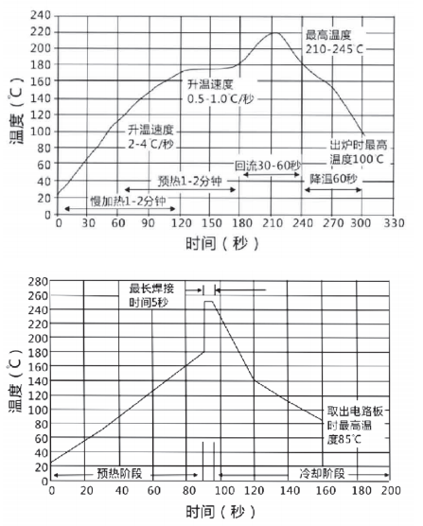

Fig.27 Recommended Soldering Curves of MLCC Series